Air Dry Clay Mixed Media Box
Created by Amy Koranek
This beautiful keepsake box is easy to make and fun to showcase!

GETTING STARTED:
Start with clean hands and work surface area. Good work surfaces include wax paper or disposable foil. Wash hands after use.

SUPPLY LIST:
- Model Air™ Terra Cotta Air Dry Modeling Clay
- Sculpey® Style and Detail Tool Set
- Sculpey® Acrylic Roller
- Paper Mache Box
- Scrapbook papers – 4 different patterns
- Spray Adhesive
- 2 different Ribbons – 1.5” W (9”) and 7/8” W (39”)
- Scissors
- Ruler
- Brown ink pad
- Glue dots
- Fast drying clear glue

INSTRUCTIONS
STEP 1
Use spray adhesive to cover the box as desired with scrapbooking paper. We used a different paper for the sides and lid to add interest.

STEP 2: Decorating the lid
Use 2 different patterned papers. Cut the bottom piece to 5 1/2" H x 4 1/4” W. Tear the edges and use Brown ink to antique them. Cut a 3” square from another patterned paper. We chose a gold piece and crumpled it to give it a distressed look. Use spray adhesive to adhere the bottom paper to the lid. Place the top piece of paper on a diagonal and use spray adhesive to secure it down.

STEP 3: Adding the ribbons
Cut a 9” L piece of the 1.5” W ribbon and place it across the top of the box (tucking the ends onto the inside lid of the box) using glue dots to adhere it down. Cut a 9” L piece of the 7/8” W ribbon and place it on top of the 1.5” W ribbon using glue dots to keep it in place (again tucking the ends of the ribbon to the inside lid of the box). Then take the 30” of the 7/8” W ribbon and wrap it around the sides of the box, using glue dots to keep it in place.

STEP 4
For the clay design, we took inspiration from the scrapbooking paper. You can use your own papers for inspiration or use the floral design that we did. It will be best if you create one floral motif and then repeat. This way you will have more time to stick all the clay elements together before they begin drying.

To create the floral motif:
- Create a vine shape. You will add each element in place on the vine as you make them.
- For the large flower elements, make 3 little teardrops for the calyx.
- Make a bell shape for the base of the flower.
- Make 8 petals to set inside the flower base.
- Make a ball for the center of the flower.
- Press all the elements together as shown in the photo. Gently score lines in the base of the flower.

STEP 5
- To make the large leaf you will need to make a large club shape, four medium clubs and two small clubs. To make a club – roll a log and taper one end.
- Place all the clubs together with the sides touching. Press them flat so that they form one solid leaf.
- You can use one of the tools dipped in water to detail the leaf. Repeat for a second leaf. Place the leaves on the vine.

Step 6
For the curlicues, you can shape simple candy cane shapes and add these to the vine as desired.

Step 7
For little pod details, make three little club shapes and press them together sides touching. Add 3 small balls on top of the middle club for seeds. Put one of these on the vine next in the middle of the curlicue.

STEP 8
Once your piece is fully assembled, allow it to dry completely.

STEP 9
Repeat steps 4 -8 to make the other half of the floral motif.

STEP 10
Attach both pieces to the box using fast-drying, clear glue.

TIP: Add metal pieces, buttons and other embellishments to enhance the mixed media look.

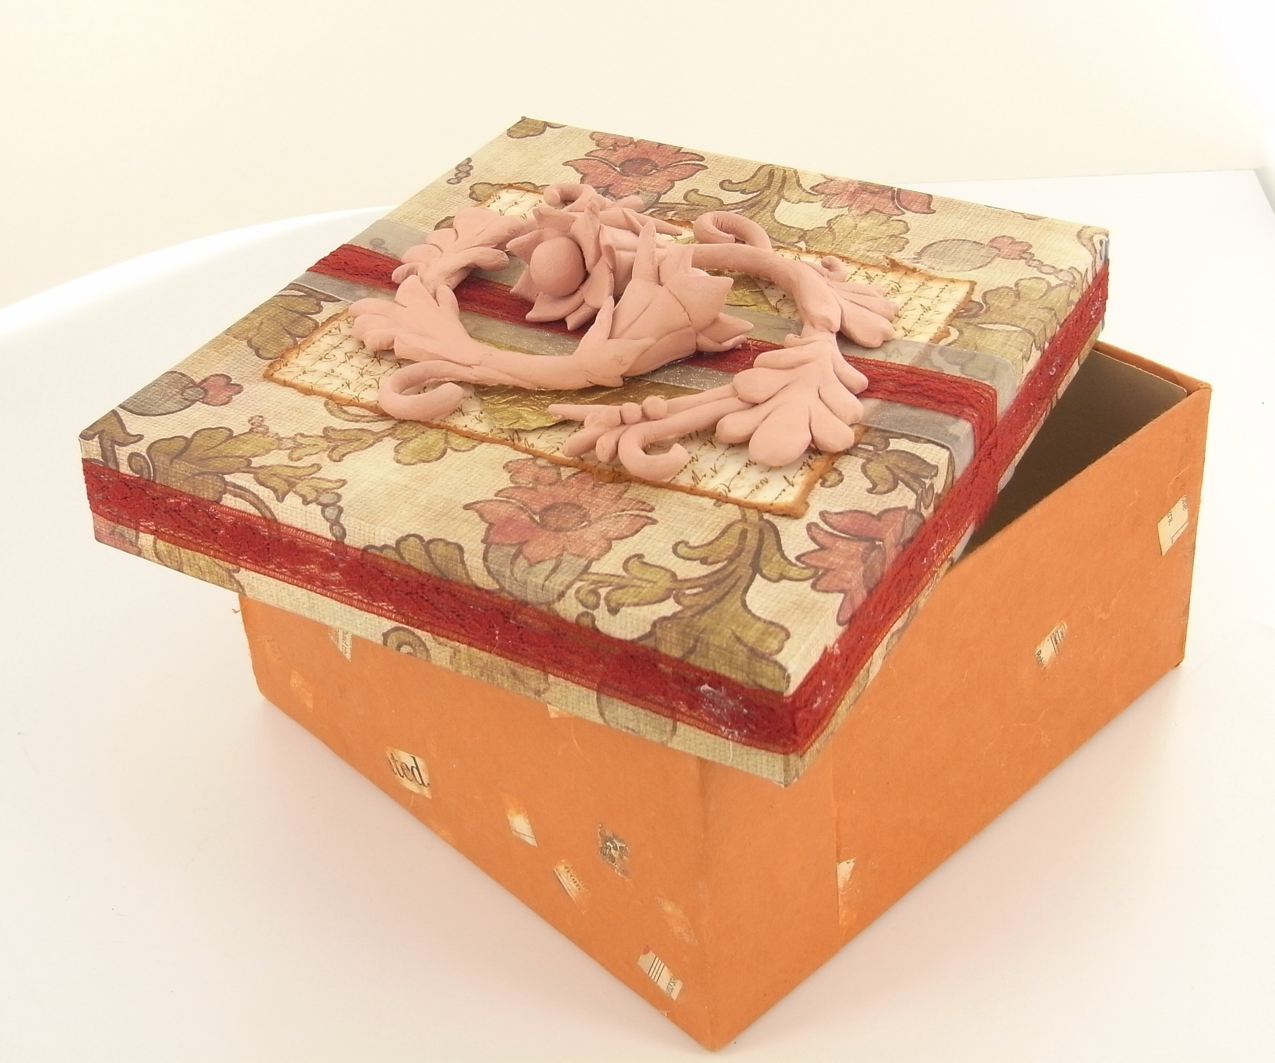
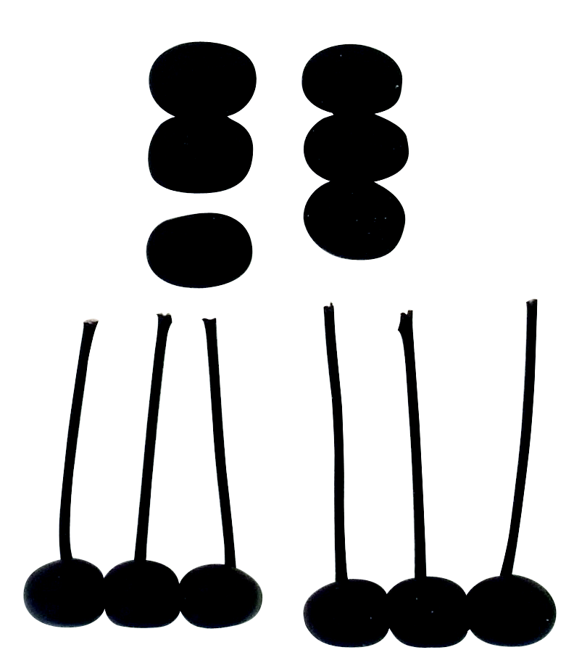
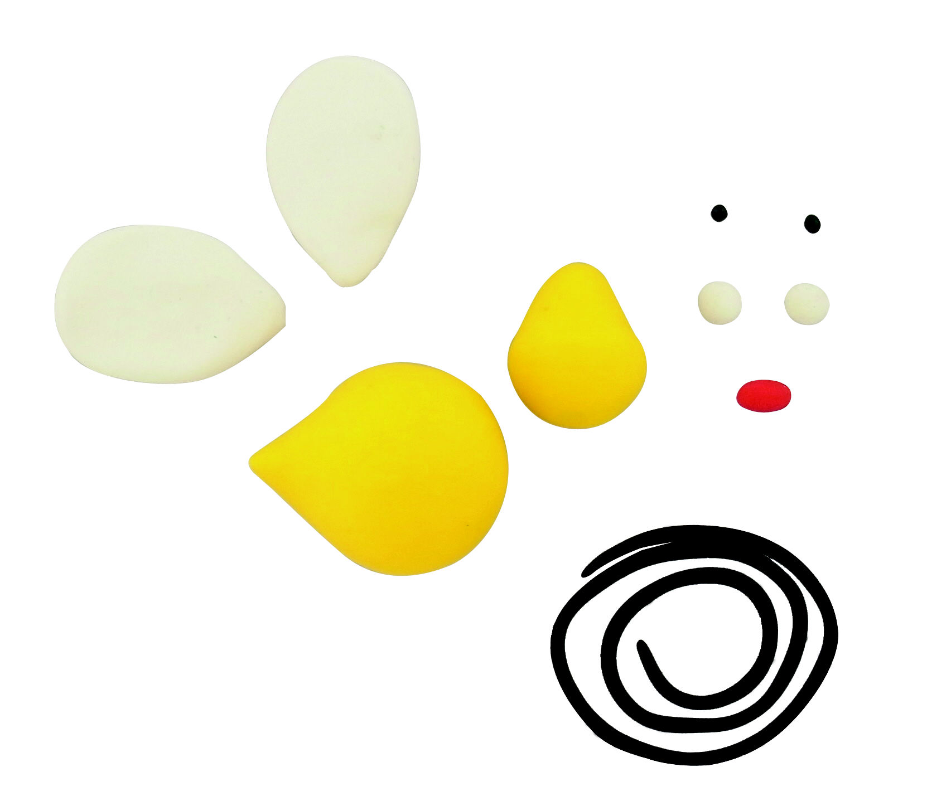

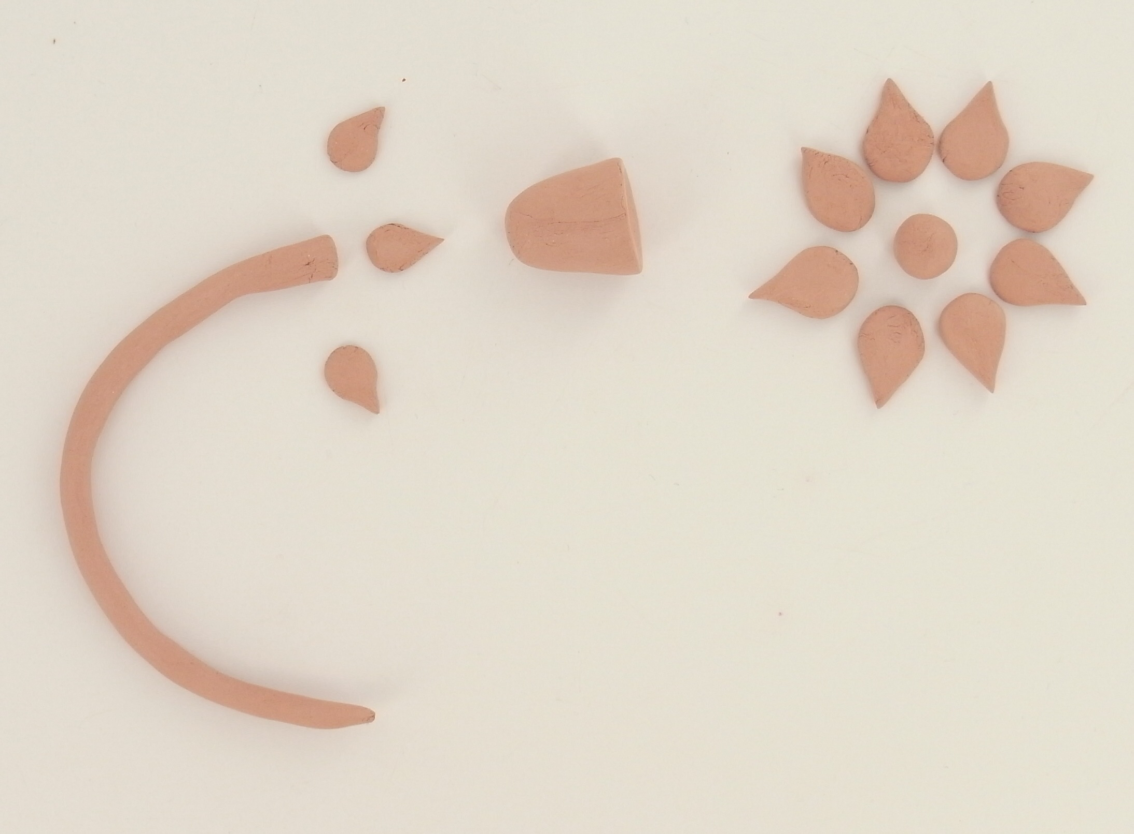
©2012 Polyform Products | 1901 Estes Avenue Elk Grove Village, IL 60007 | www.sculpey.com
