Air Dry Clay Flowers in Pot
Created by Amy Koranek
These beautiful flowers will brighten up anyone’s day!!

GETTING STARTED:
Start with clean hands and work surface area. Good work surfaces include wax paper or disposable foil. Wash hands after use.

SUPPLY LIST:
- Model Air™ Terra Cotta Air Dry Modeling Clay
- Sculpey® Clay Tool Variety Set
- Sculpey® Acrylic Roller
- Cookie cutters in flowers, circles, and assorted shapes
- Five 1/4" dowel rods
- Acrylic paints – Dark and Light Green, Blue, White, Yellow, Orange
- Paint brush

INSTRUCTIONS
STEP 1
Paint 3 Dowel Rods Dark Green and the other 2 Light Green. Set aside to dry completely.

STEP 2
Using the acrylic roller, roll clay out to a 3/16" thick sheet. Cut out 5 base shapes using the flower and circle cookie cutters. Cut out 3 flowers and 2 circles. Press a dowel rod into each of the base shapes.

STEP 3
Using the Acrylic Roller, roll clay out to a 3/16" thick sheet. Cut out 5 more shapes using a slightly smaller cookie cutter than your base shapes. Sandwich the next shape over the dowel rod.

STEP 4
Using the Acrylic Roller, roll clay out to a 3/16" thick sheet. Cut out 5 more shapes using a slightly smaller cookie cutter than your 2nd layer shapes. Layer more shapes on top as desired. Add texture details with clay tools as desired.

STEP 5
Allow to dry completely. Paint as desired or follow finished photo for inspiration.

TIP: Add ribbons around the stems and gemstones to the flowers for a mixed media look!

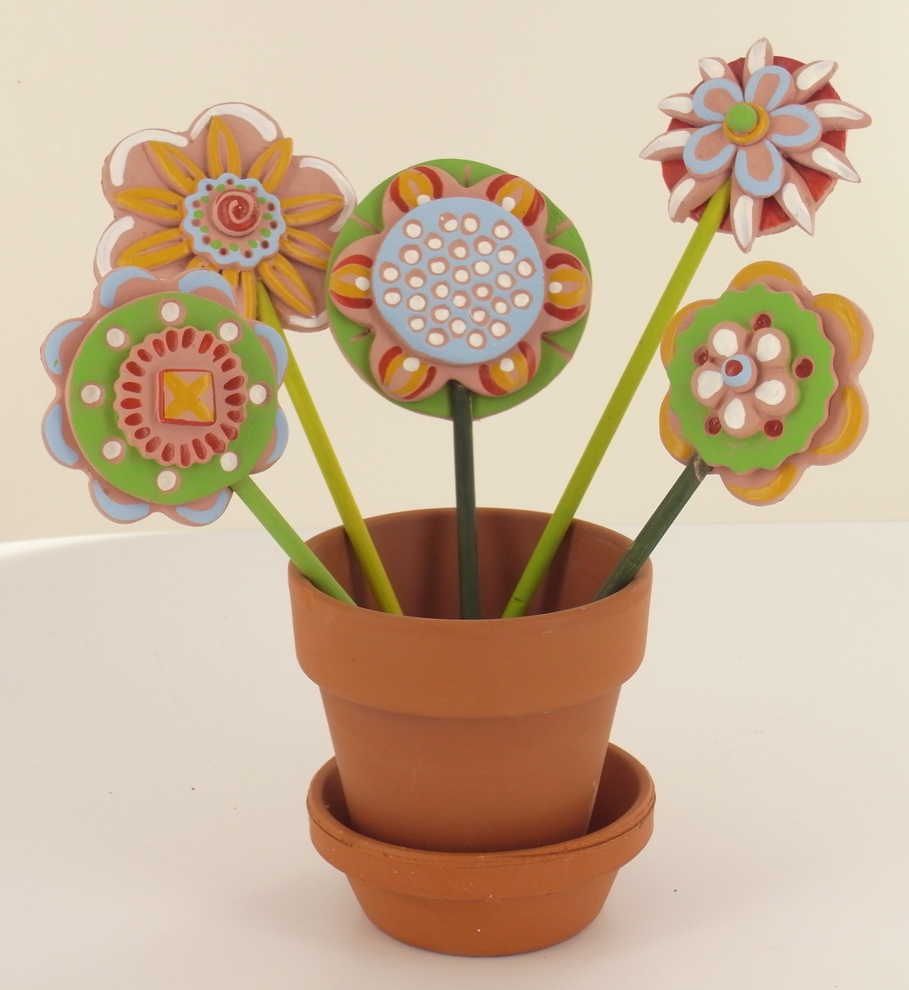
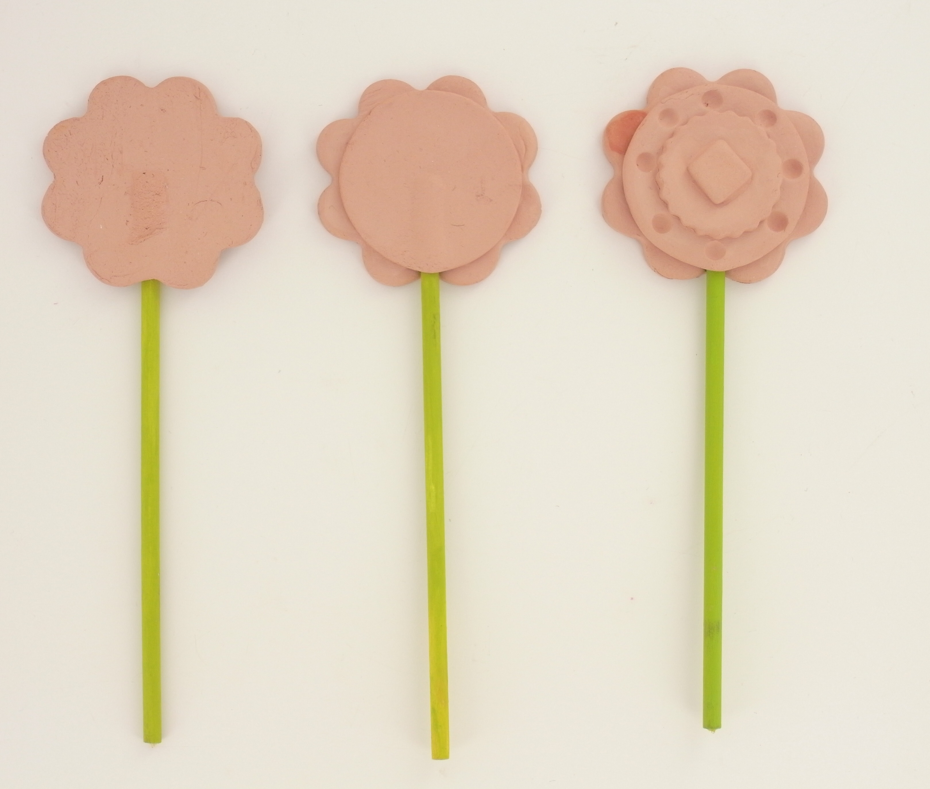
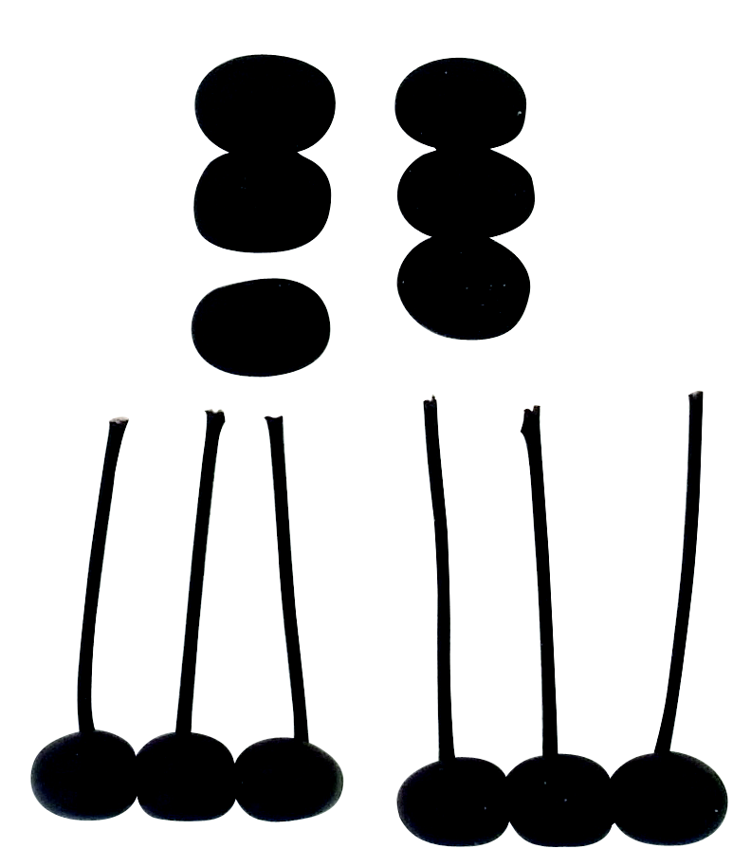
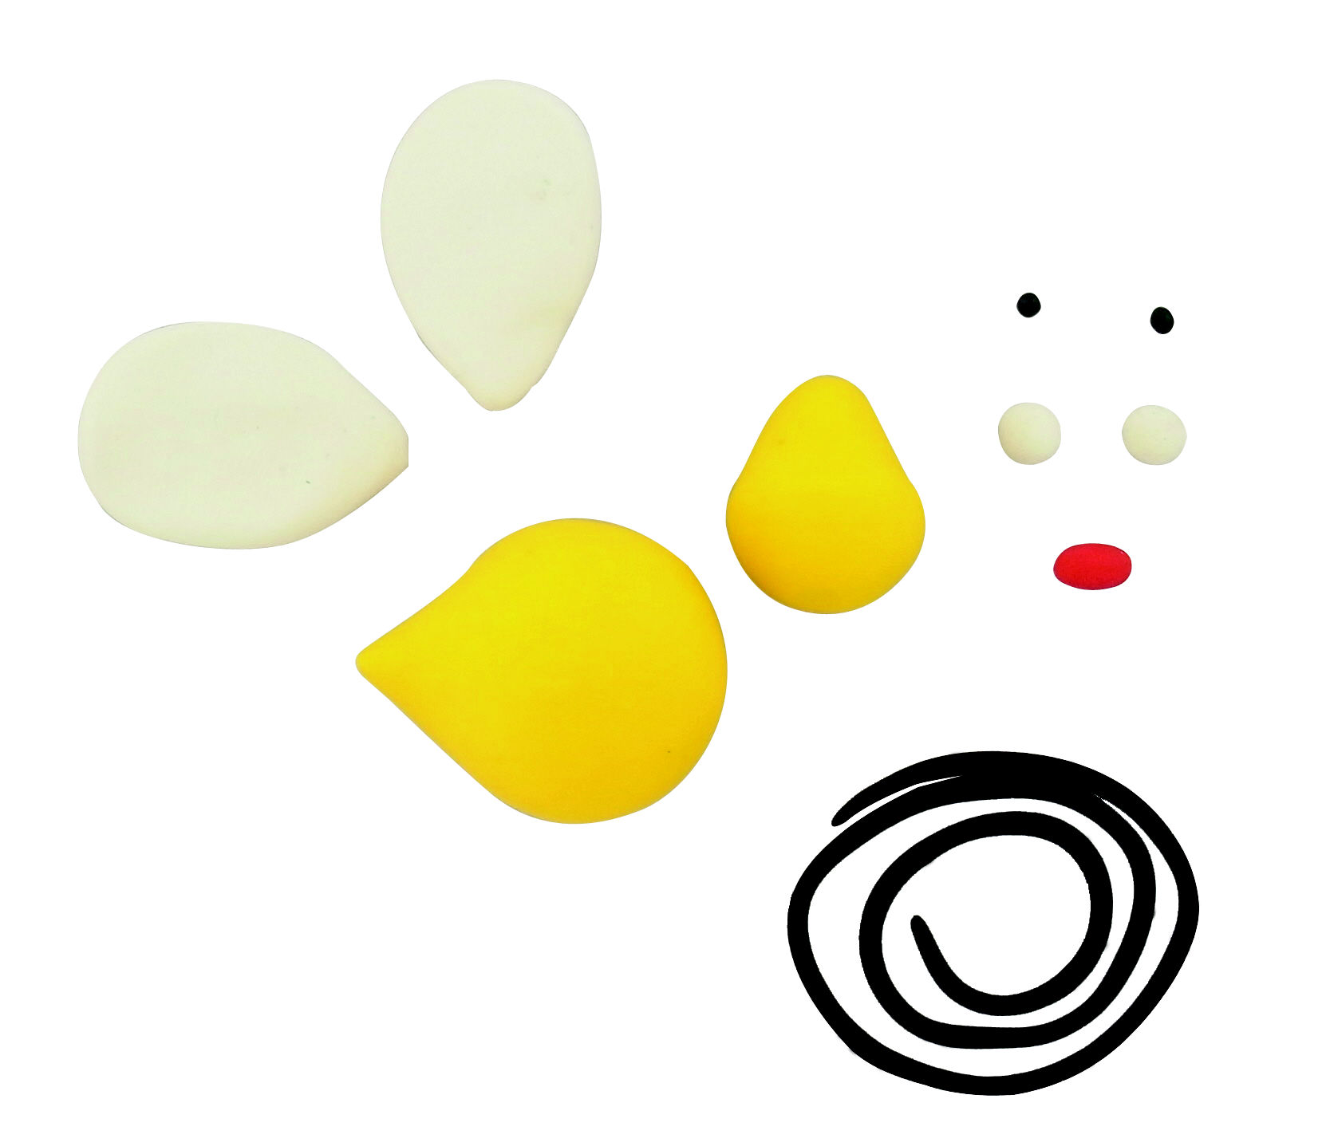
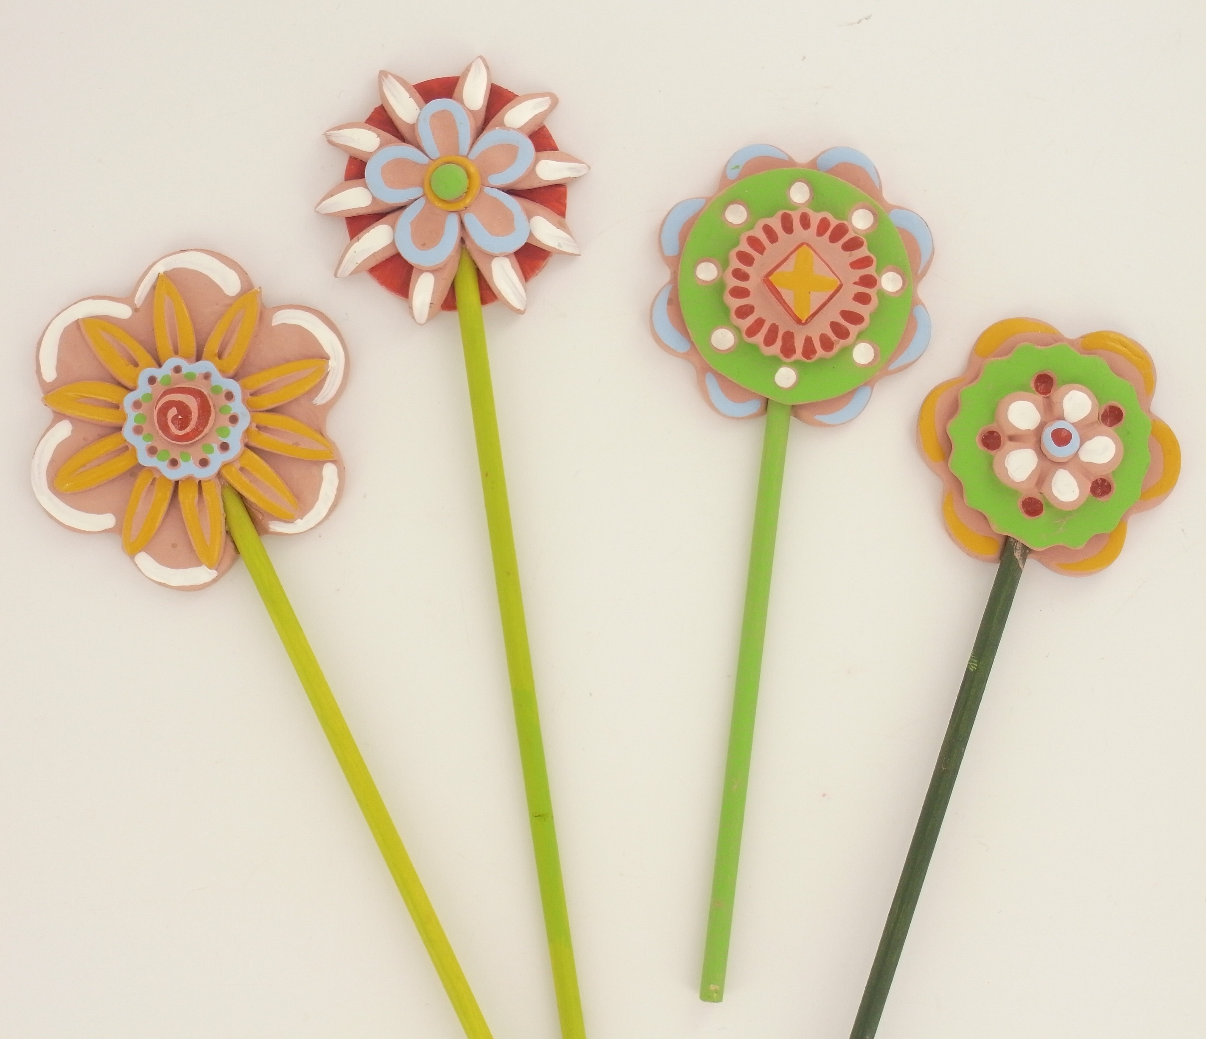
©2012 Polyform Products | 1901 Estes Avenue Elk Grove Village, IL 60007 | www.sculpey.com

