Air Dry Clay Pencil Cup
Created by Britta Lautenschlager
This pencil cup makes staying organized fun and easy!

GETTING STARTED:
Start with clean hands and work surface area. Good work surfaces include wax paper or disposable foil. Wash hands between each color.

SUPPLY LIST:
- Model Air™ White Air Dry Modeling Clay
- Model Air™ Terra Cotta Air Dry Modeling Clay
- Sculpey® Super Slicer
- Sculpey® Acrylic Roller
- Sculpey® Plastic Modeling Tool Set
- premo! Sculpey® Crinkle Cutter Set
- Acrylic Paint: Brown, Yellow, Black, Tan, Cream, Gray, Dark Green, Green
- Paint Brush
- Empty Soup Can
- Fast drying, clear glue

INSTRUCTIONS
STEP 1
Using the Acrylic Roller, roll out a thin sheet of Terracotta air dry clay. Using the Super Slicer cut a rectangle to fit around a soup can and smooth the seam (approx. 8 3/4” W x 3 7/8” H). Set aside to dry completely.

STEP 2: Tree
Using the White air dry clay make the following pieces:
  - Make one flattened rectangle and shape into the tree stump (approx. 2” H x 7/8” W). Using the modeling tools make 2 cuts in the top for branches.
  - Make one large oval for the leaves. Using the modeling tool lightly add texture
  - Assemble pieces as shown
  - Let dry completely
  - Paint using acrylic paints in Brown and Green, allow to completely dry
STEP 3 Giraffe
Using the White air dry clay make the following pieces:
  - Make one large tear drop shape and stretch the pointy end to shape into the neck (approx 2”L)
  - Make two long logs (approx 1” L) for the legs
  - Make one snake, slightly thicker on one end for the tail (approx 1 1/4” L). Flatten thicker end and using the modeling tool cut into it for the tail hair.
  - Make one small flattened oval shape for the head (approx 15/16”), slightly larger on one side
  - Make two small club shapes (approx 1/2” L) for the horns
  - Make one tiny ball (approx. 1/16”) for the eye
  - Make one small tear drop for the ear (approx 3/8” L)
  - Assemble all pieces as shown. Let completely dry
  - Paint using acrylic paints in Yellow, Black and Brown allow to completely dry
STEP 4 Lion
Using the White air dry clay make the following pieces:
  - Using the acrylic roller, roll out a sheet of clay. Using the round crinkle cutter cut out one shape for the mane.
  - Make one oval shape for the body (approx. 1”)
  - Make two short logs for the legs (approx. 1/2”)
  - Make one snake with a point at one end for the tail (1 3/8” L)
  - Make two small flattened balls for the muzzle (approx 1/4”). Using modeling tool poke small dots into each
  - Make two small balls for the ears (approx. 3/16”)
  - Make two very small balls for the eyes (approx. 1/16”)
  - Make one small ball for the mouth (approx. 1/8”)
  - Make one triangle for the nose (approx. 1/8”)
  - Assemble all pieces as shown. Let completely dry
  - Paint using acrylic paints in Black, Tan, Cream and Brown allow to completely dry
STEP 5 Clouds
Using White air dry clay make two flattened ovals (approx. 1 1/8”). Let dry completely

STEP 6 Grass
Using White air dry clay, make 9 short thin snakes and fold in half. Let dry completely and then paint using both Dark Green and Green paint. Allow paint to completely dry.

STEP 7 Rocks
Using White air dry clay, make two ovals (approx. 1”), Let dry completely and then paint using Grey acrylic paint.

STEP 8
Glue all pieces to the can using fast drying clear glue.

Tip – Make different animals if your child has a favorite. Or try another theme like pirate, princess or under the sea!

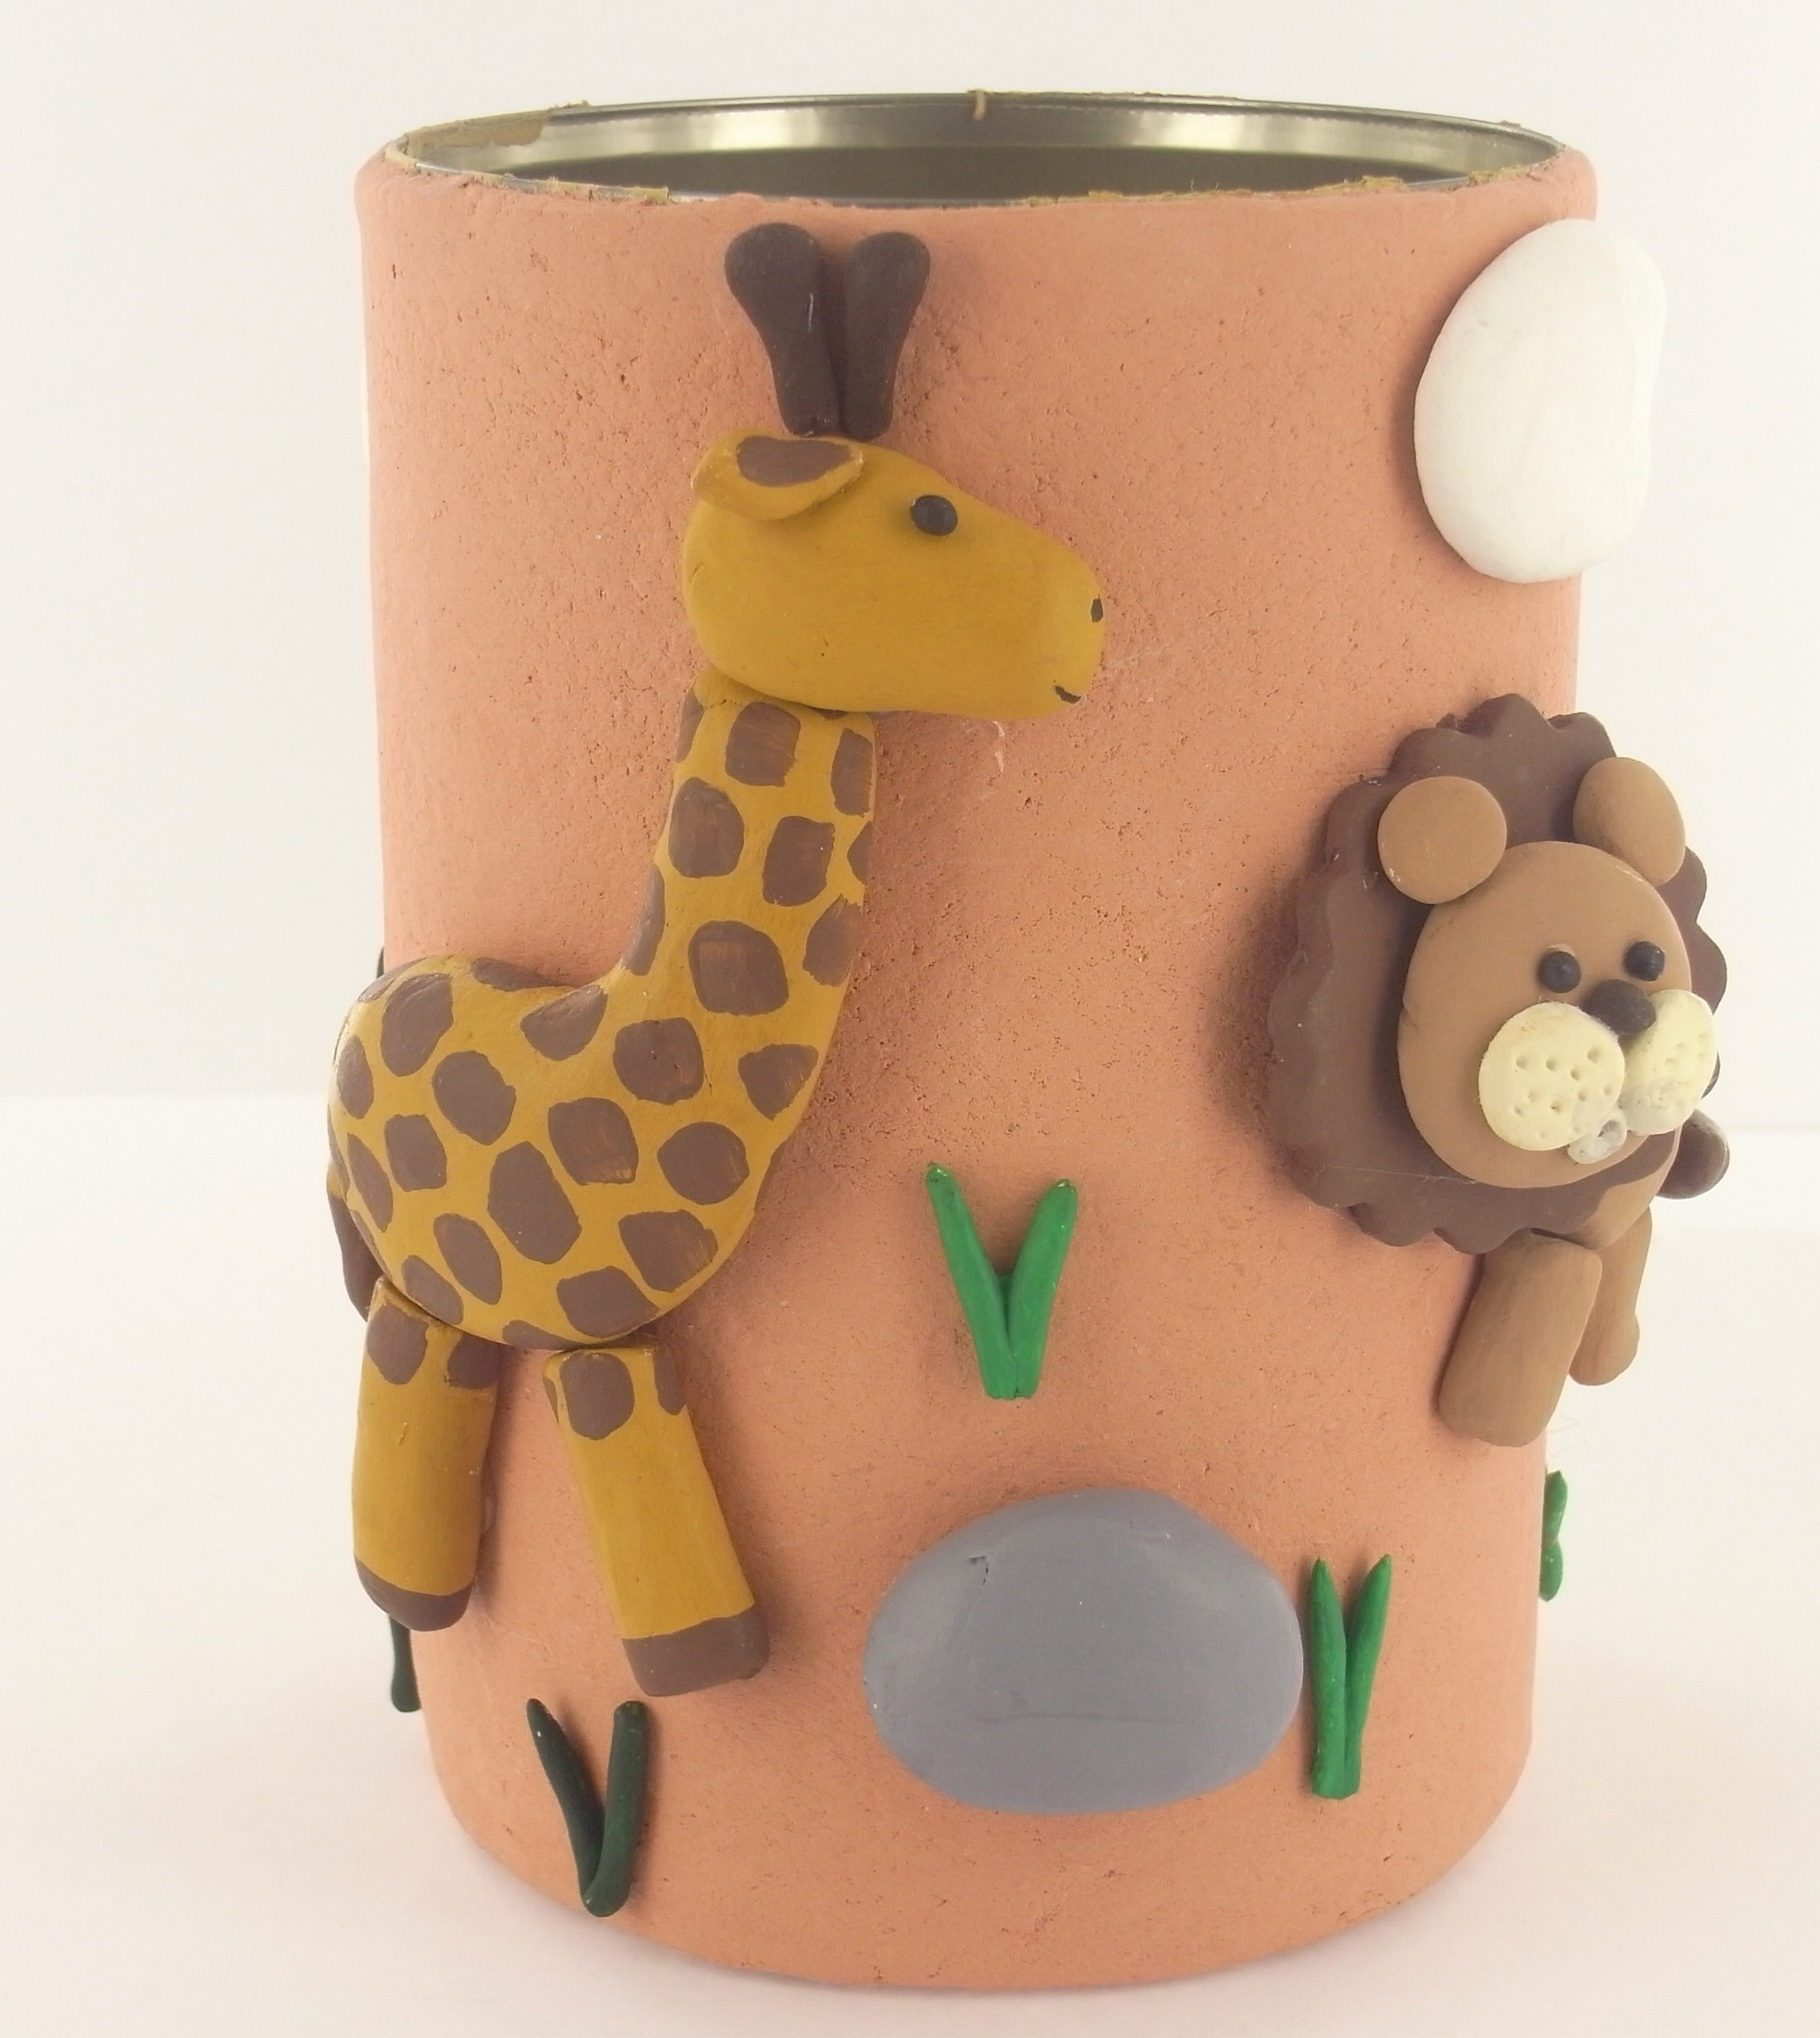
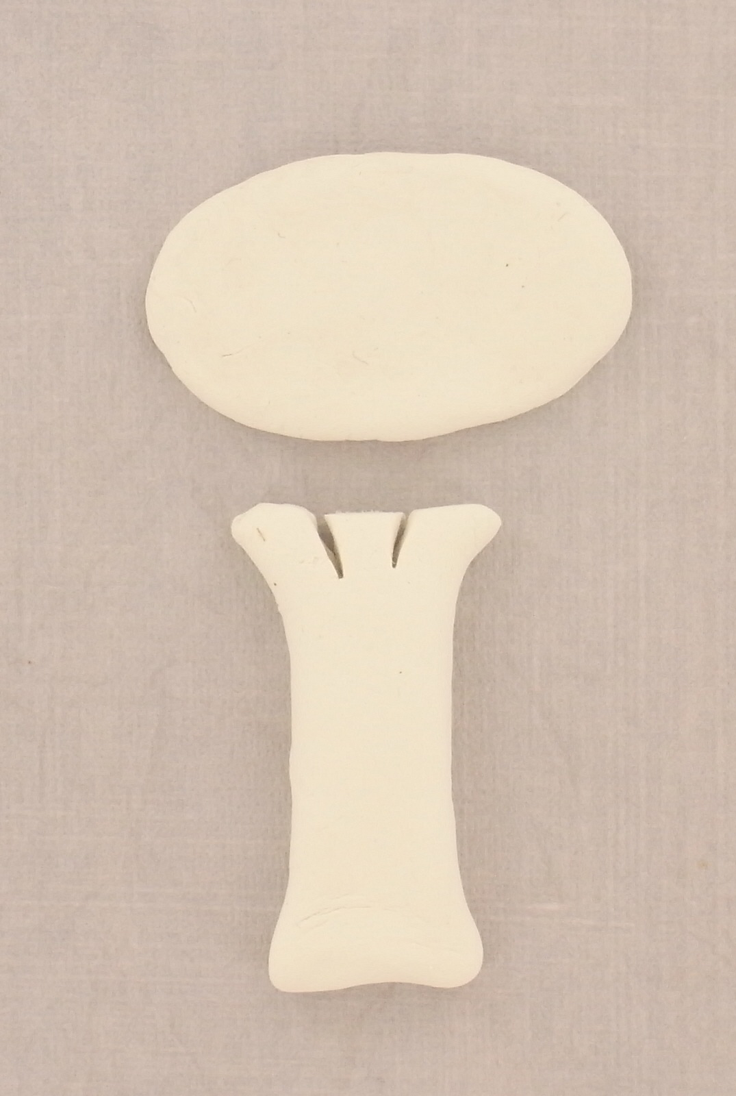
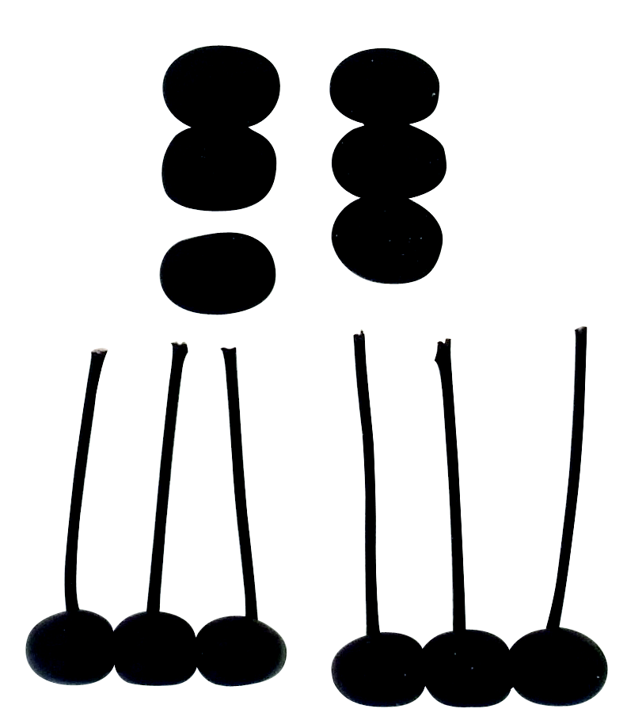
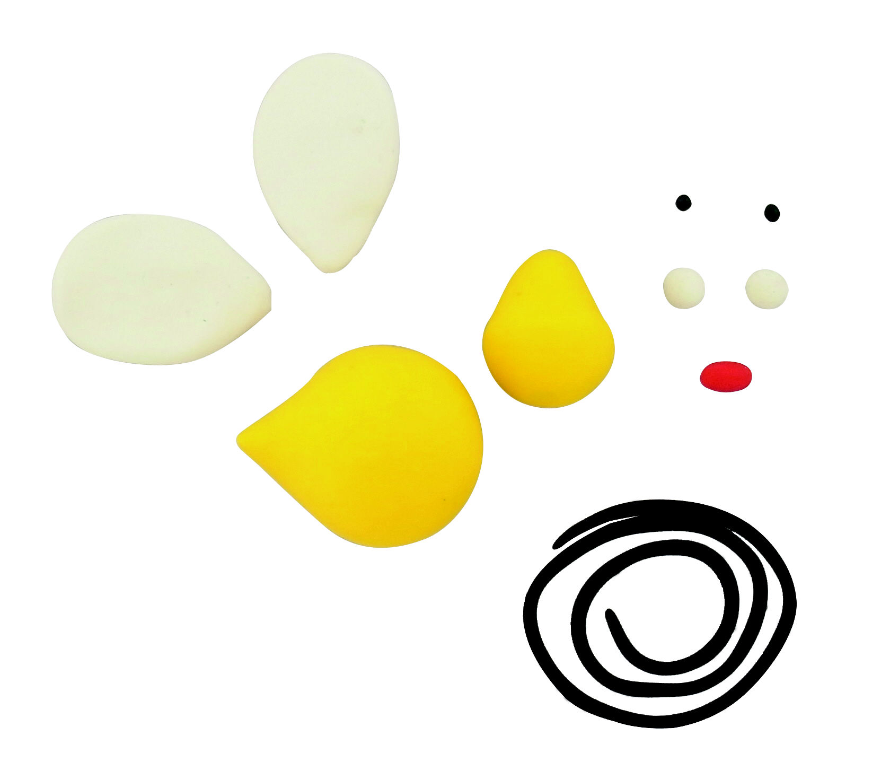

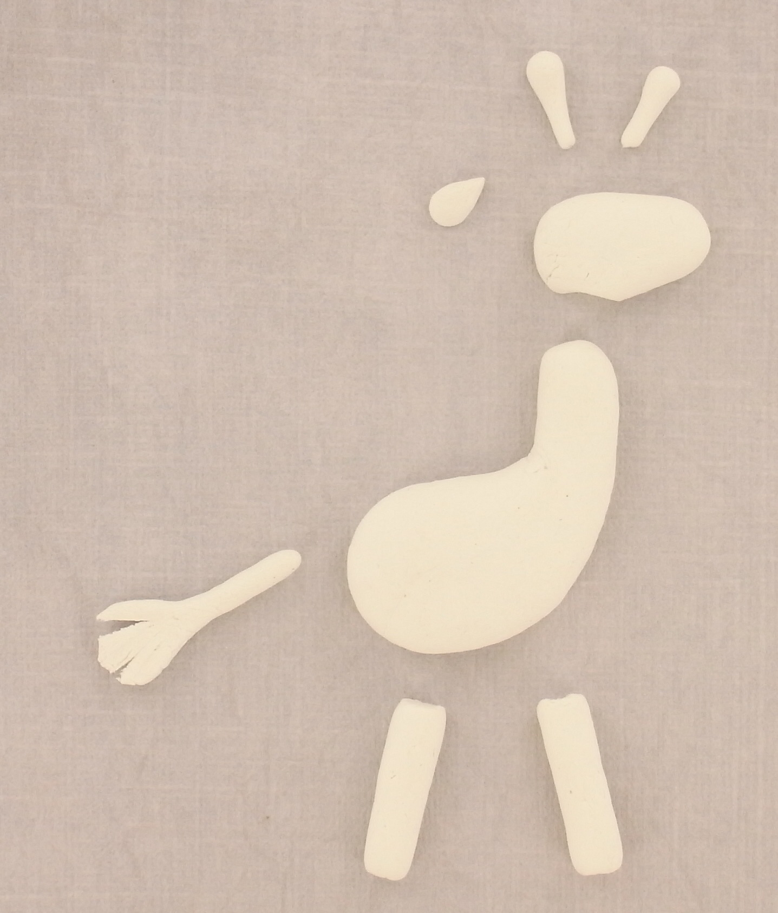
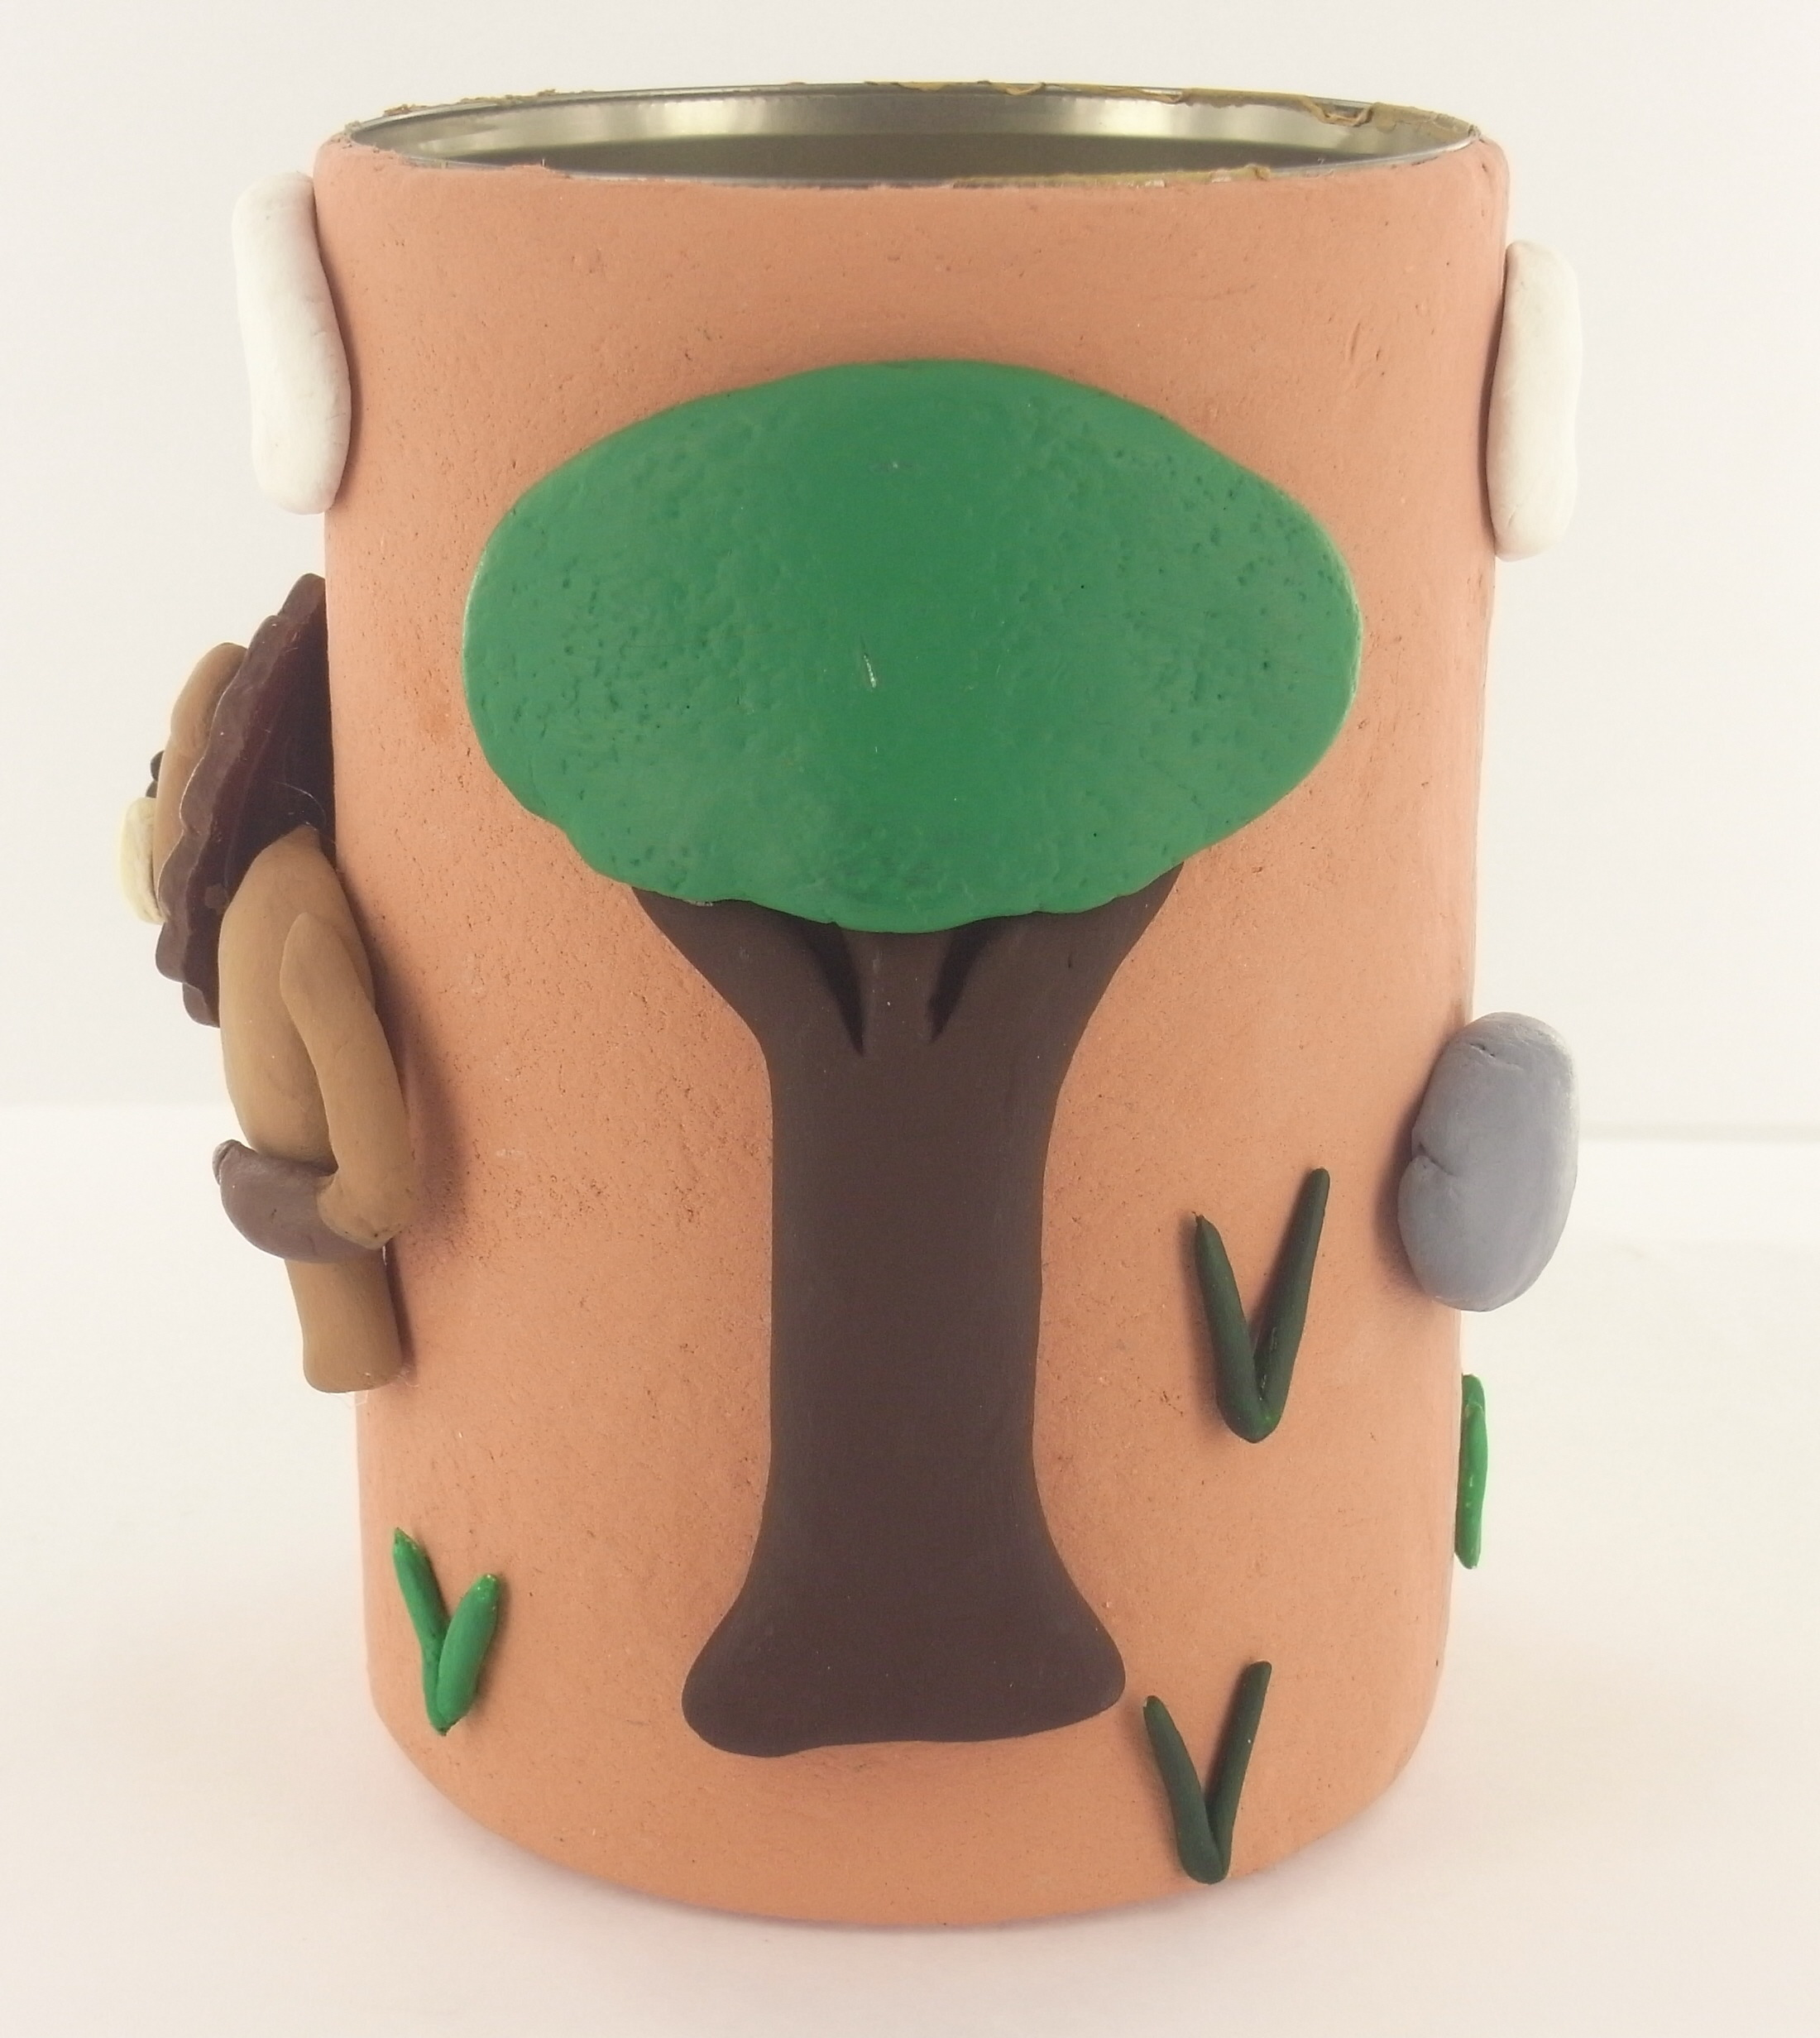
©2012 Polyform Products | 1901 Estes Avenue Elk Grove Village, IL 60007 | www.sculpey.com
