Air Dry Clay Plant in vase
Created by Amy Koranek
This mix of air dry and Sculpey III has an organic feel to it. The perfect accessory to add some tranquility to your office.

GETTING STARTED:
Oven Bake Clay
Do not use unbaked clay on unprotected furniture or finished surfaces. Start with clean hands and work surface area. Good work surfaces include wax paper, metal baking sheet, or disposable foil. Knead clay until soft and smooth. For best results, clean your hands in between colors. Shape clay, pressing pieces together firmly. Bake on oven-proof glass or metal surface at 275 °F (130 °C) for 15 minutes per 1/4" (6 mm) thickness. For best baking results, use an oven thermometer. DO NOT USE MICROWAVE OVEN. DO NOT EXCEED THE ABOVE TEMPERATURE OR RECOMMENDED BAKING TIME. Wash hands after use. Baking should be completed by an adult.
Begin by preheating oven to 275 °F (130 °C). Test temperature with oven thermometer for perfectly cured clay. For best results, condition all clay by running it through the clay dedicated pasta machine several passes on the widest setting. Fold the clay in half after each pass and insert the fold side into the rollers first.

Air Dry
Start with clean hands and work surface area. Good work surfaces include wax paper or disposable foil. Wash hands after use.

SUPPLY LIST:
- Model Air™ White Air Dry Modeling Clay
- Sculpey® III String Bean and Translucent
- Sculpey® Style and Detail Tool Set
- Sculpey® Clay Conditioning Machine

INSTRUCTIONS
STEP 1: Making the bowl
- Make a ball using White air dry clay. Press your thumb deep inside the ball to create a cavity. Work the cavity open with your thumb.
- Pinch the sides of the bowl upward to thin them and make the bowl taller and more open. Gently move the sides of the bowl inward pressing from the top toward the bottom and the right side toward the left.
- Using White air dry clay, make 20 small balls and 4 small crescent shapes and attach to the outer sides of the bowl. Set aside and allow to dry completely.

STEP 2
- Mix 4 parts Translucent clay to 1 part String Bean clay.
- Press a thumb sized pad of the green mixture into the bottom of the bowl (this will be your base for the plant).
- Make lots of small thin logs that come to a point on one end out of the green clay in various lengths.
- Press each log into the bottom of the bowl attaching it to the pad. Start at the outer edge of the pad and press each piece in place with the medium sized ball tool. Keep adding logs, working from the outside edge to the middle until the bowl is full. Allow the logs to fall randomly over the sides of the bowl.
- Make tiny logs and sprinkle them down in between the long logs to add more variety.

STEP 3
- Bake the bowl and the plant at 275 °F (130 °C) for 15 minutes.

TIP: To add interest, try using different color clay for the plants.

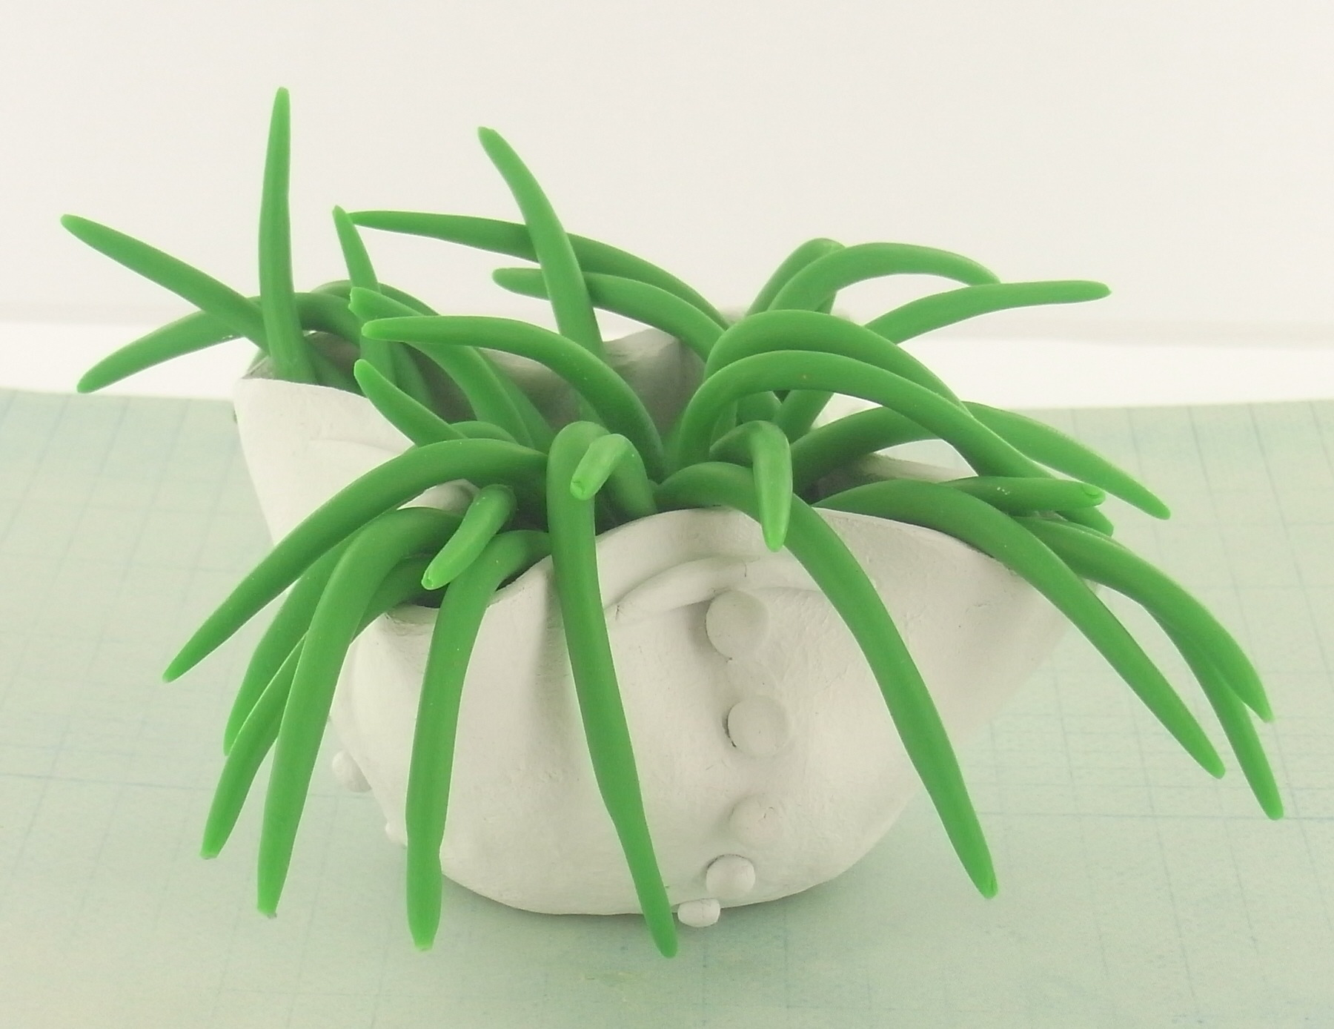
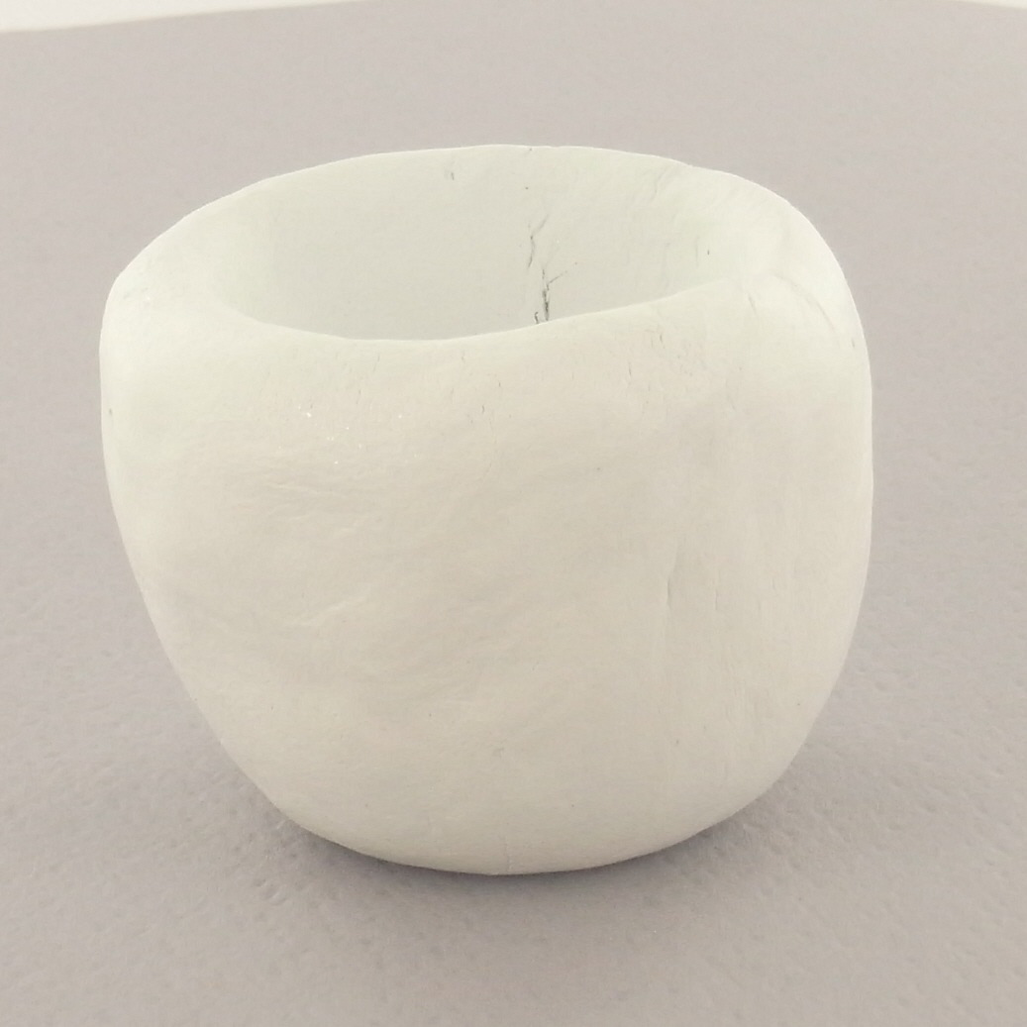
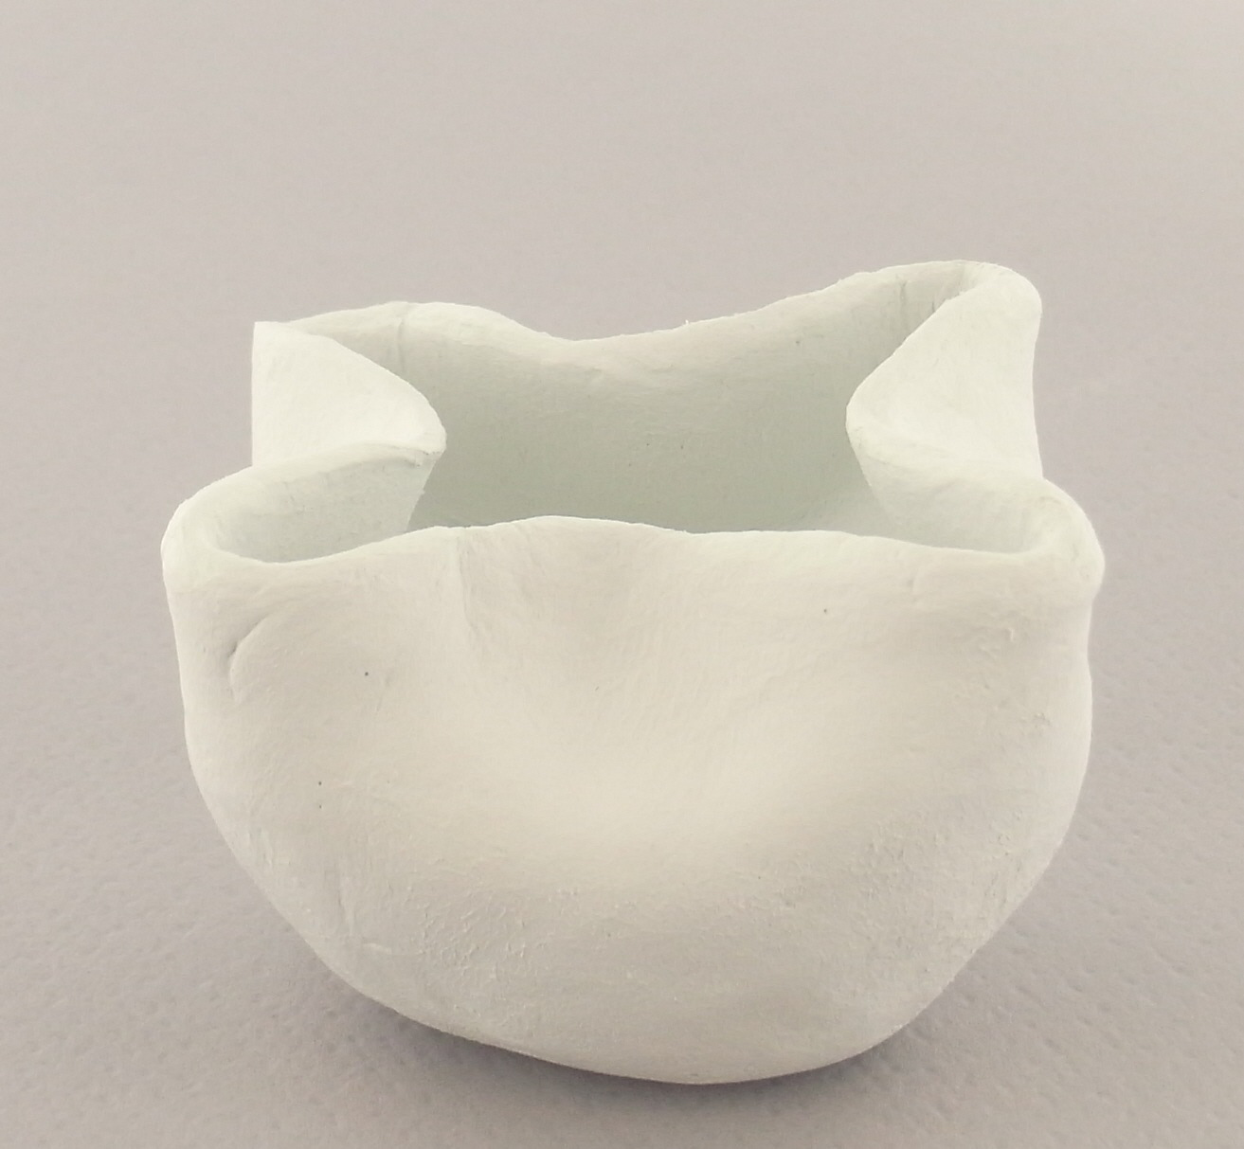
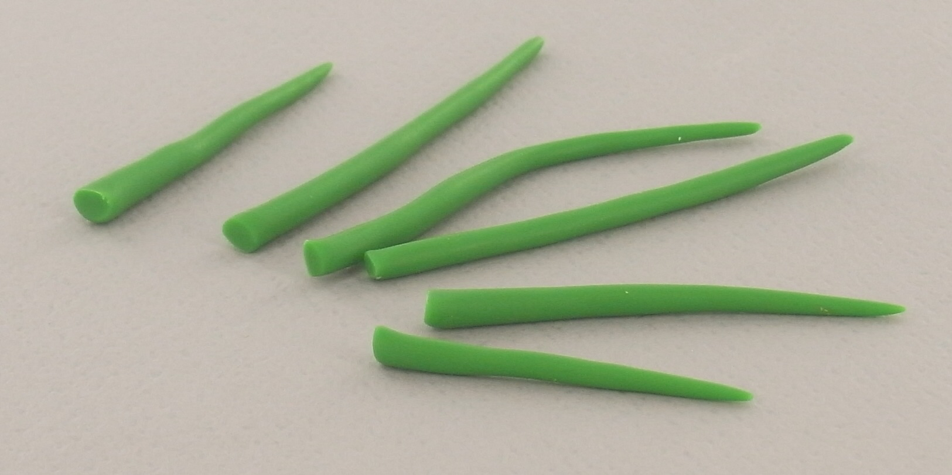
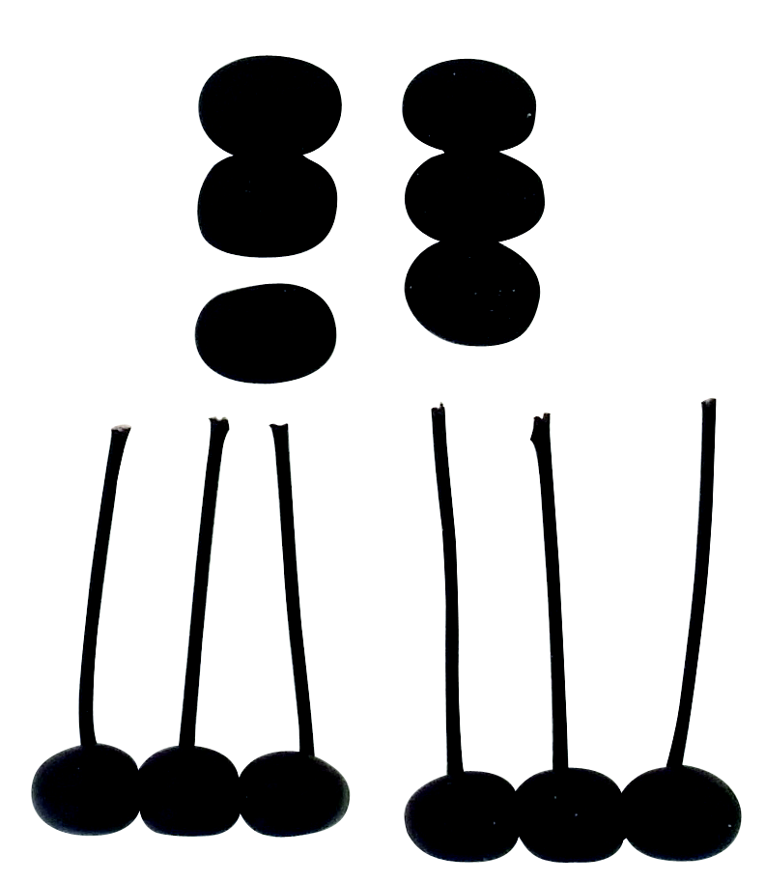
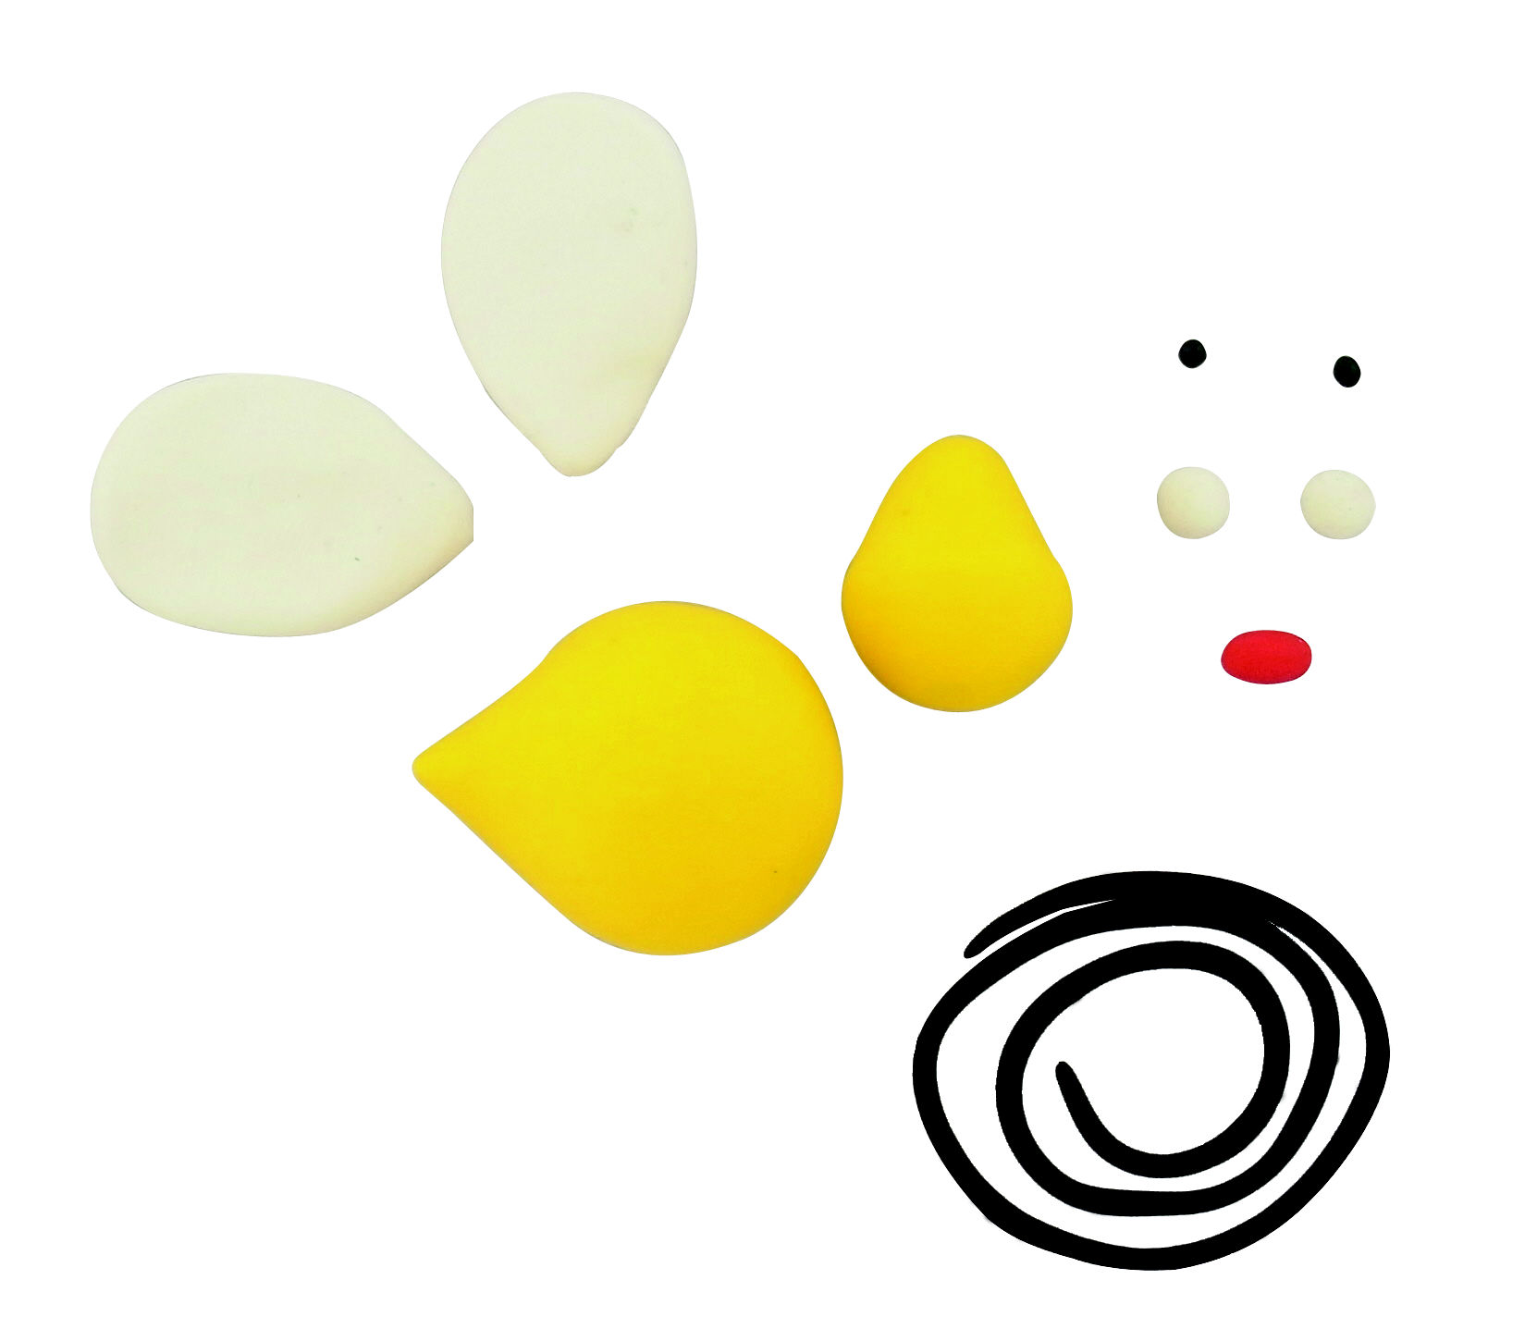
©2012 Polyform Products | 1901 Estes Avenue Elk Grove Village, IL 60007 | www.sculpey.com

