Sculpey III-Bachelorette Invite
Created by Keri Lee Serika

This show stopping invitation will get really get your friends attention!
GETTING STARTED:
Do not use unbaked clay on unprotected furniture or finished surfaces. Start with clean hands and work surface area. Good work surfaces include wax paper, metal baking sheet, or disposable foil. Knead clay until soft and smooth. For best results, clean your hands in between colors. Shape clay, pressing pieces together firmly. Bake on oven-proof glass or metal surface at 275 °F (130 °C) for 15 minutes per 1/4" (6 mm) thickness. For best baking results, use an oven thermometer. DO NOT USE MICROWAVE OVEN. DO NOT EXCEED THE ABOVE TEMPERATURE OR RECOMMENDED BAKING TIME. Wash hands after use. Baking should be completed by an adult.
Begin by preheating oven to 275 °F (130 °C). Test temperature with oven thermometer for perfectly cured clay. For best results, condition all clay by running it through the clay dedicated pasta machine several passes on the widest setting. Fold the clay in half after each pass and insert the fold side into the rollers first.
SUPPLY LIST:
Scupley® III: Black, White, Candy Pink, Granny Smith, Silver
Sculpey® Gloss Glaze
Premo! Sculpey ® Crinkle Cutters: Geometric (oval)
Premo! Sculpey ® Mini Cutters: Wedding (shoe, ring, heart)
Sculpey ® Acrylic Roller
Sculpey ® Super Slicer
Sculpey ® Etch 'n Pearl
Sculpey ® Clay Mat
Cardstock: Bright Pink, Pale Green
White Computer Paper
Ribbon: Black Satin & Silver Cording
Ultrafine Glitter
Small Glue Dots
Paper Cutter
Scissors

INSTRUCTIONS
Step 1
Condition 1/2 bar of white and 1/2 bar of black. Roll each color in to a log, to avoid color transfer wipe hands in between with baby wipes. Place the logs side by side and twist the two colors together. When the colors begin to form stripes fold the log in half and twist again. Push from both ends towards the center to make the log shorter and thicker. Once you have stripes you are happy with, shape the log into a thick rectangular shaped cane (the height and width of the cane should be large enough to fit the cutter shapes).

Step 2
Slice off 3 pieces from the cane about 1/8” thick.

Step 3
Using the Shoe and Heart Mini Cutters, cut out 2 shoes and 1 heart.

Step 4
Using the Acrylic Roller, roll out a 1/8” thick sheet of Candy Pink, use the Heart Mini Cutter to cut out three hearts. Sprinkle with iridescent glitter

Step 5
Roll out a 1/8” thick sheet of Granny Smith. Use the Oval Crinkle Cutter to cut out 1 oval. Use the pointed tip of the Etch 'n Pearl to make small hole in top of oval.

Step 6
Roll out a 1/8” thick sheet of Silver and a very thin sheet of White. Use the Ring Mini Cutter to cut out 1 Silver ring and 1 White ring. Use a craft knife to cut the top part of the ring off the white shape. Layer the white “diamond” on top of silver ring. Use the tip of the small Etch 'n Pearl to create diamond facets. Sprinkle iridescent glitter on the white “diamond”. Use the concave end of the medium Etch ‘n Pearl to cut out the hole in the ring.

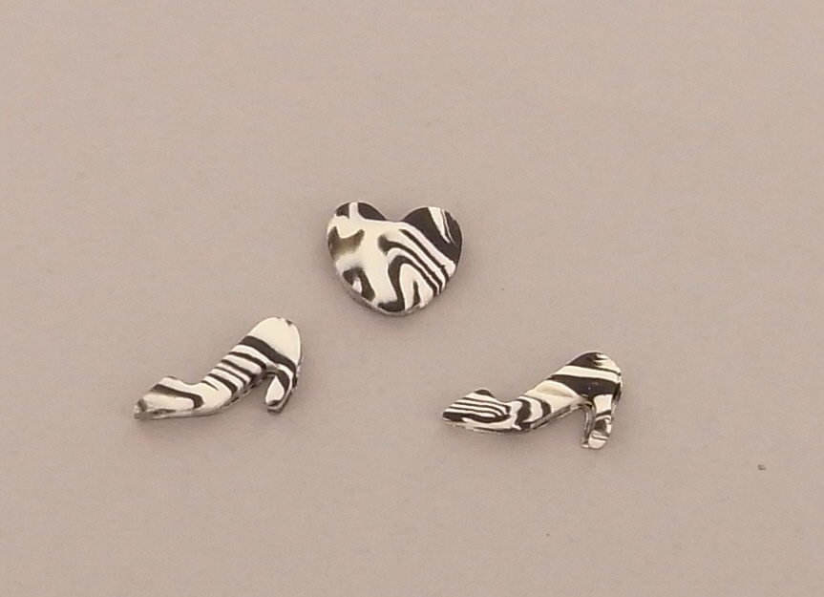
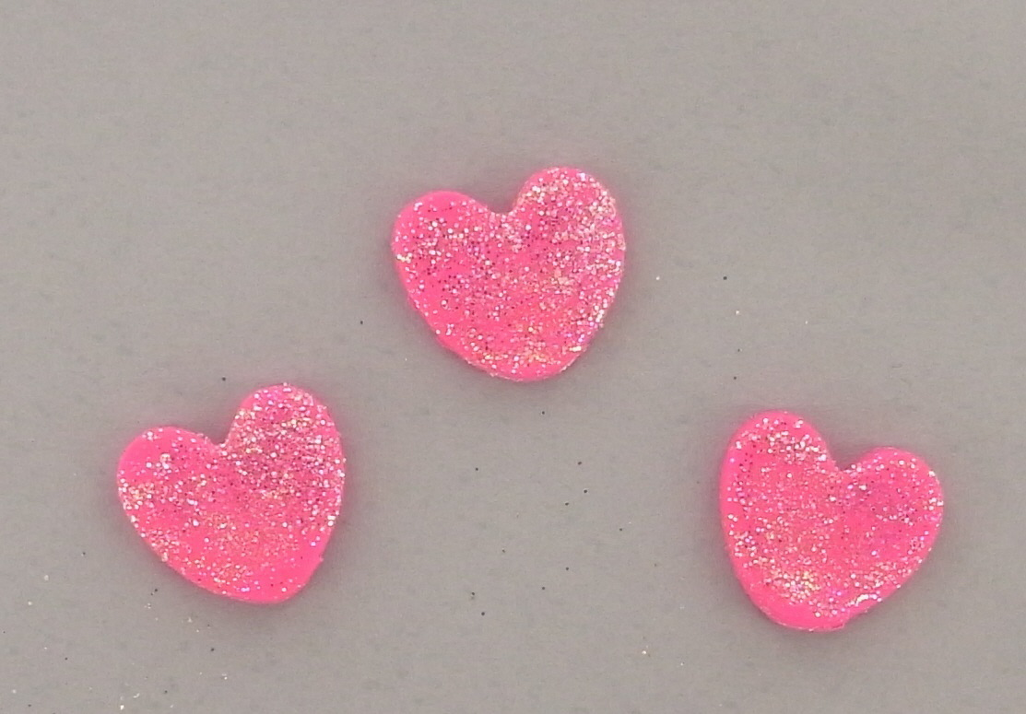

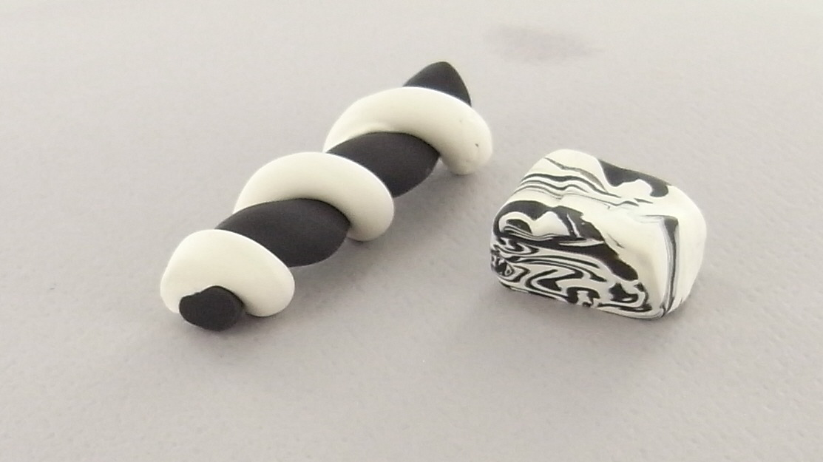

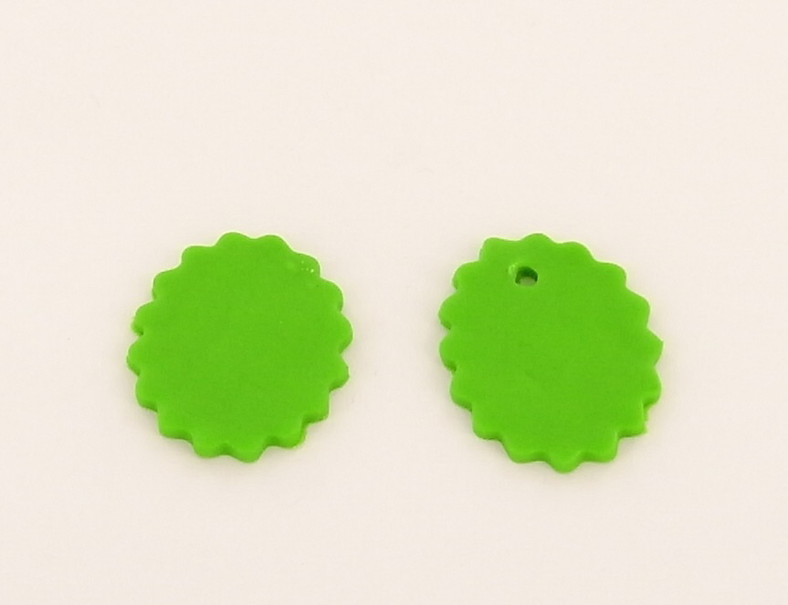

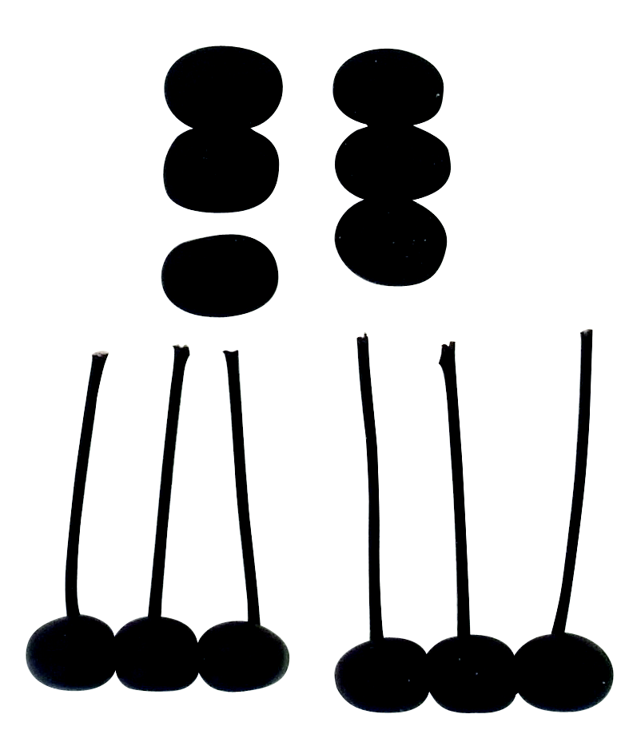
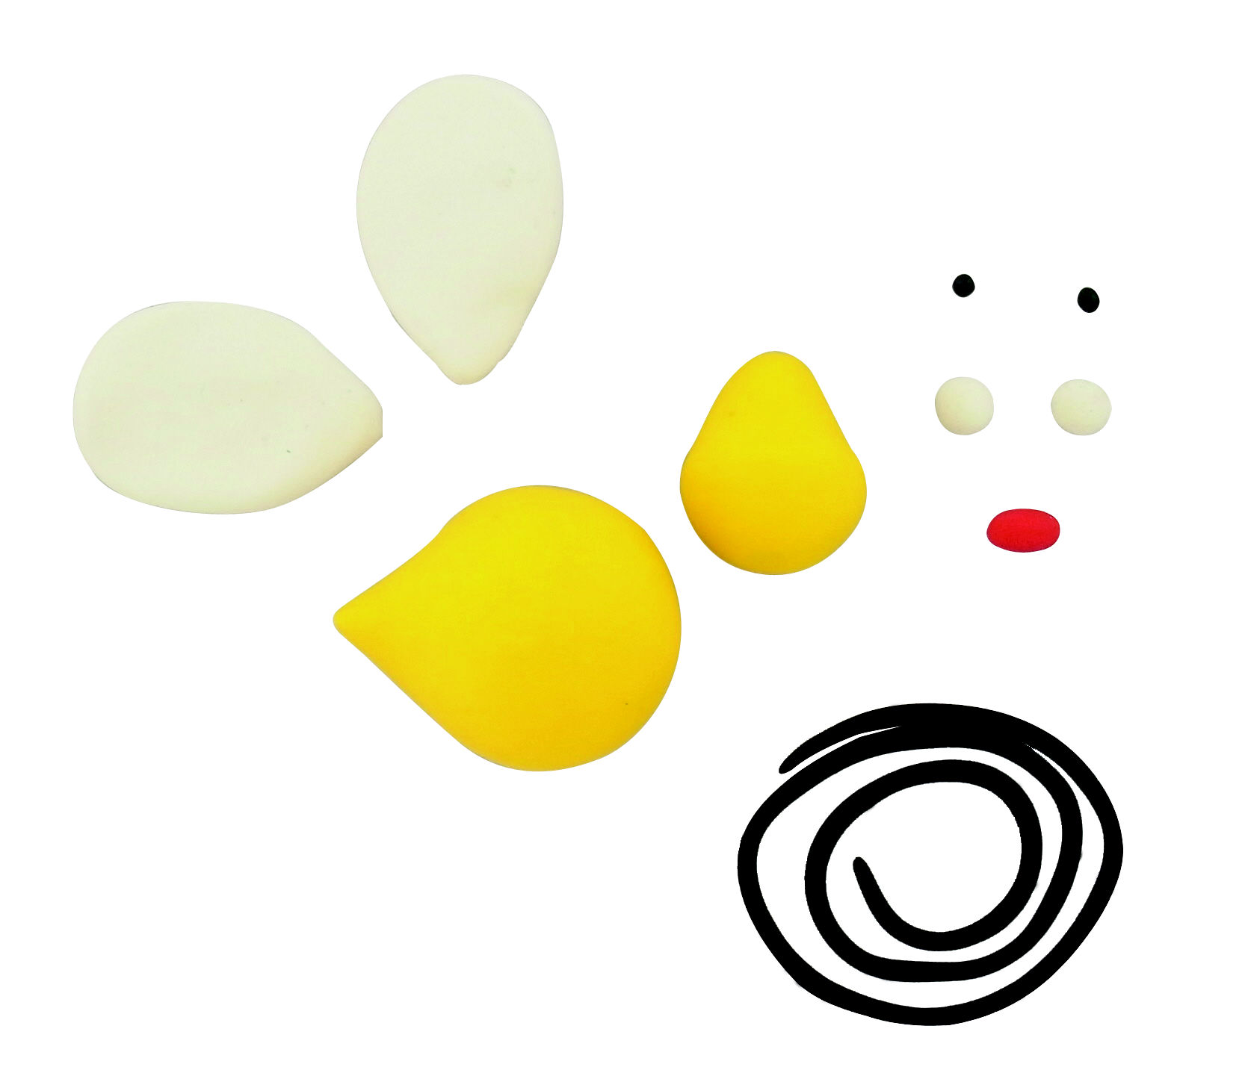
INSTRUCTIONS

Step 7
Bake all clay pieces according to the manufacturer’s instructions. Once cool, you can add Glossy Glaze to give the pieces a little extra shine.

Step 8
Cut pink cardstock to 5”x7”. Print invitation details onto computer paper, trim to 6 3/4” x 4 3/4”. Cut two strips of pale green cardstock 1” x 4 3/4”. Adhere to top and bottom of white paper. Tie a short length of black satin ribbon around bottom edge of top green cardstock strip. Tie a short length of silver cording through center of knot, this will be used to hold the ring charm in a later step. Adhere printed paper to pink mat, set aside until clay charms and pieces are ready to embellish invitation.

Step 9
Use a glue dot to adhere ring to Granny Smith charm. Tie to center of ribbon knot using silver cording.

Step 10
Adhere remaining clay embellishments as shown to complete invitation.

