Sculpey III-Bouquet Charm
Created by Amy Koranek

Add this charm to the bride’s bouquet or as great accessory for your bridesmaid’s flowers!
GETTING STARTED:
Do not use unbaked clay on unprotected furniture or finished surfaces. Start with clean hands and work surface area. Good work surfaces include wax paper, metal baking sheet, or disposable foil. Knead clay until soft and smooth. For best results, clean your hands in between colors. Shape clay, pressing pieces together firmly. Bake on oven-proof glass or metal surface at 275 °F (130 °C) for 15 minutes per 1/4" (6 mm) thickness. For best baking results, use an oven thermometer. DO NOT USE MICROWAVE OVEN. DO NOT EXCEED THE ABOVE TEMPERATURE OR RECOMMENDED BAKING TIME. Wash hands after use. Baking should be completed by an adult.
Begin by preheating oven to 275 °F (130 °C). Test temperature with oven thermometer for perfectly cured clay. For best results, condition all clay by running it through the clay dedicated pasta machine several passes on the widest setting. Fold the clay in half after each pass and insert the fold side into the rollers first.
SUPPLY LIST:
Sculpey III® Oven-bake Clay – Pewter
Sculpey® Acrylic Roller or Clay Dedicated Pasta Machine
Sculpey® Stamper – Alphabet
Premo! Sculpey® Metal Cutters, Mini – Wedding
Sculpey® Super Slicer
Toothpick
Circle Cutter or Quarter, Small
Rhinestone (oven safe), Large
Fast Dry Clear Glue
Jump Rings – Silver (3)
Glass Beads (5)
Head Pins (5)
Pliers
Ribbon
Rubber Stamp Ink (Optional)
Drinking Straw

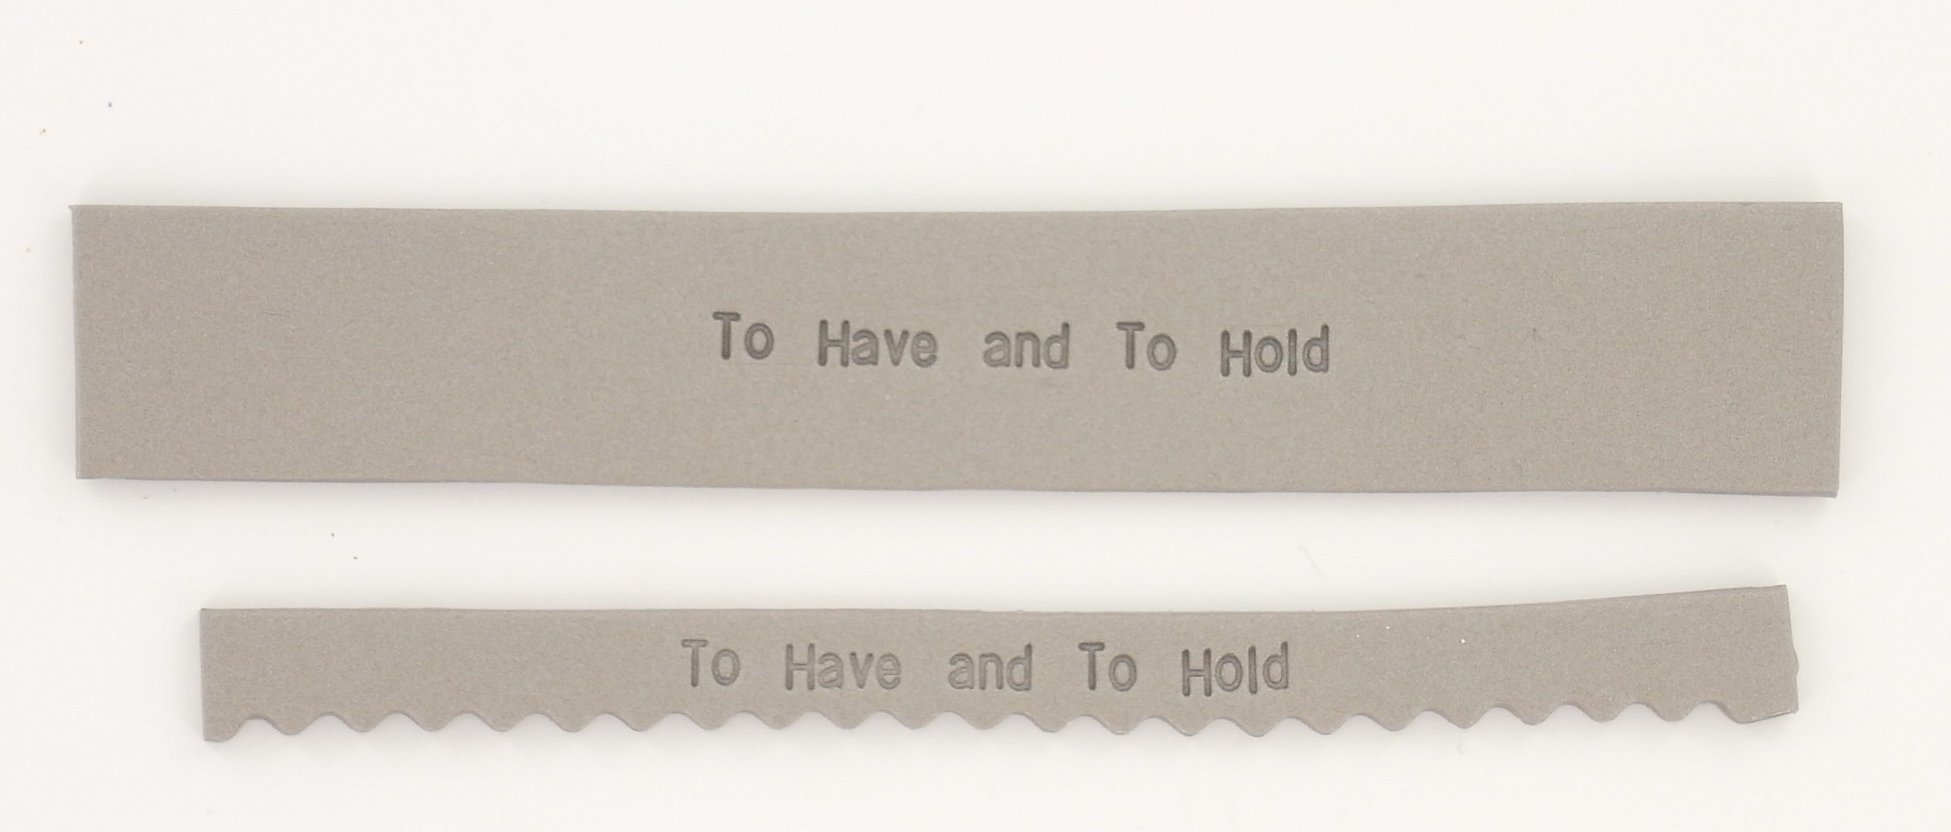
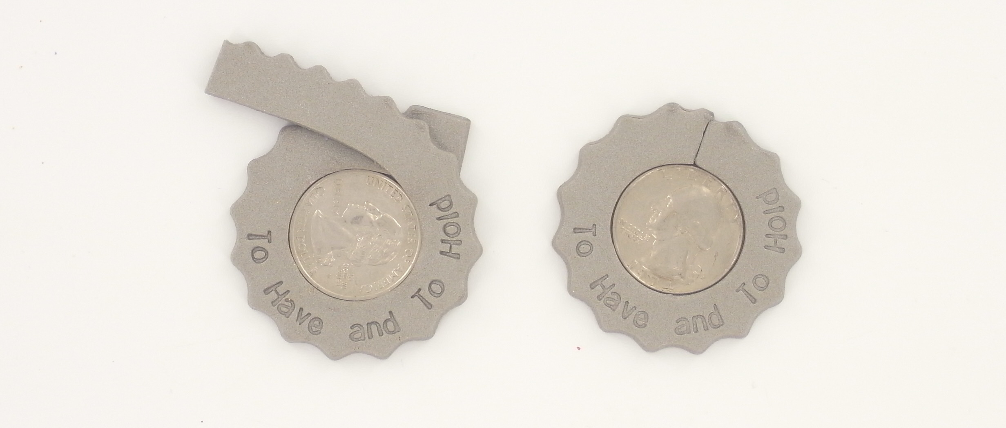
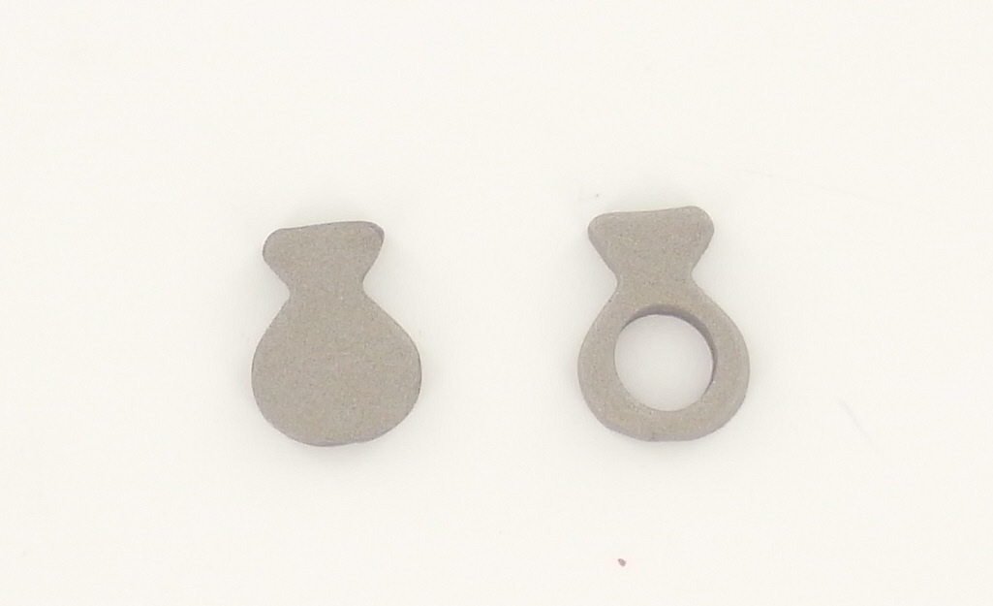
INSTRUCTIONS
STEP 1
Roll out a sheet of pewter clay to about 1/8" thick. The piece of clay should be at least 1" wide and 6" long. Set up the alphabet stamper with a phrase that you would like to imprint in the clay.

STEP 2
Trim underneath the phrase with the Super Slicer wavy blade. Trim above the phrase with the straight blade.

STEP 3
Lay the quarter or other circle template in front of you. Place the clay strip with the center of the phrase at the 6 O'clock position. Gently bend the clay around the circle template making sure the clay strip stays flat as you bend it. Make sure the tail ends of the clay strip overlap each other completely.
Using the straight blade, cut a seam through both layers of the tail ends of the clay strip. Remove the excess clay trimmings. Gently smooth the seam with your finger.

STEP 4
Roll out a sheet of pewter clay about 1/8" thick. Using the ring shape from the mini metal cutter set, cut out the ring shape. Cut out the band area of the ring shape with the end of a drinking straw. Gently press a large rhinestone (make sure you are able to bake it) into the ring shape. If your rhinestone is flat-backed, you will want to glue it in permanently with clear fast drying glue.

STEP 5
Using a toothpick, poke two holes into the top area of the phrase strip. These holes should be directly in the top and one above the other. Bake your project according to the manufacturer's instructions.

STEP 6
After baking, fasten the ring charm to the phrase circle with a jump ring through the bottom hole. Place another jump ring through the top hole of the phrase circle. This jump ring will be for attaching the finished charm to a bouquet with a ribbon. If desired, use the head pins to turn beads into charms. Attach the bead charms to another jump ring and fasten it to the top jump ring on the bouquet charm.

